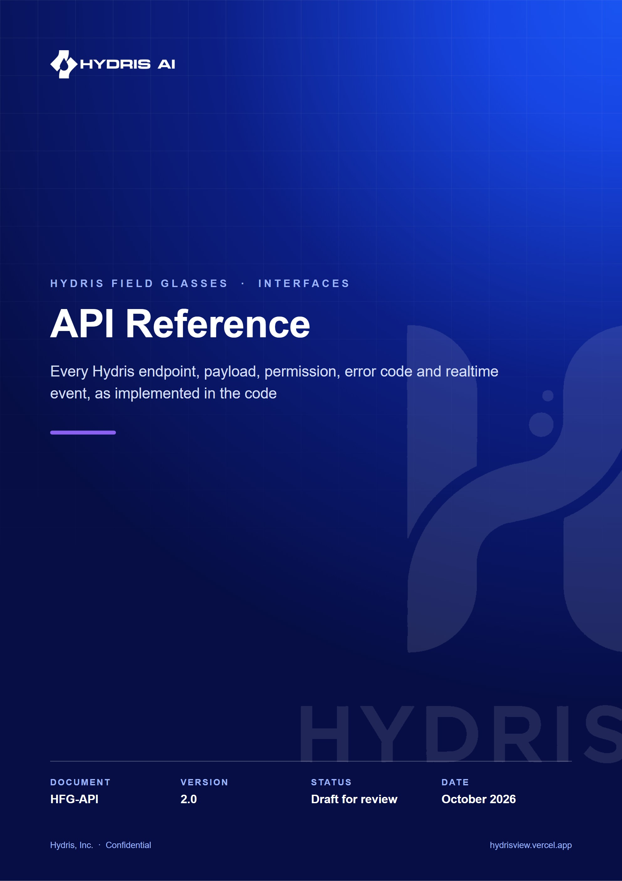
Document control
Document | API Reference (HFG-API)
Version | 2.0
Status | Draft for review
Owner | Engineering, Hydris
Audience | Backend, web, glasses and Android engineers, integration partners, QA and security reviewers
Product | Hydris Field Glasses: website, operator console, glasses app, Android app, API
Source of truth | docs/product/API_REFERENCE.md in tarun-km/hydrisview (this Word file is generated from it)
Classification | Confidential: Hydris, Inc. and named partners
Revision history
Version | Date | Author | Changes
2.0 | October 2026 | Engineering, Hydris | Complete rewrite: authentication sequences, permission matrix, full error code table, SSE event catalogue, per-endpoint entries for all fifteen modules, client notes and planned public API

Contents
1 How to read this reference 6
1.1 Endpoint entry format 6
1.2 Module map 7
2 Overview and conventions 8
2.1 Base URLs and deployment shapes 8
2.2 Versioning 10
2.3 Content types 10
2.4 Identifiers 10
2.5 Timestamps and time zones 10
2.6 Lists, filtering and pagination 11
2.7 Tenancy and site scope 11
3 Authentication and sessions 12
3.1 Password sign-in 12
3.2 Multi-factor authentication 13
3.3 Demo sign-in 14
3.4 Refresh and rotation 14
3.5 Glasses pairing 15
3.6 Device token refresh 16
3.7 Ending sessions 17
4 Authorization 18
4.1 Role and permission matrix 20
5 Errors 22
5.1 Error envelope 22
5.2 HTTP status codes 22
5.3 Error code catalogue 23
6 Rate limiting 27
7 Idempotency and concurrency 29
8 Realtime events 30
8.1 Connecting 30
8.2 Delivery modes 30
8.3 Per-connection authorization 31
8.4 Event catalogue 31
9 Health 33
10 Authentication module 34
11 Organization module 38
11.1 Platform administration 38
11.2 Organization settings 39
11.3 Members and invitations 39
11.4 Notifications 40
11.5 Audit log 40
12 Plant hierarchy and records module 41
12.1 Sites 42
12.2 Facilities and process areas 42
12.3 Assets 43
12.4 Sensors 44
12.5 Gateways 45
12.6 Documents 45
12.7 Attachments 46
12.8 History and hierarchy 47
13 Telemetry module 48
14 Alarms module 53
15 Inspections module 57
15.1 Templates 58
15.2 Routes 59
15.3 Inspections 60
16 Maintenance module 62
17 Devices and pairing module 65
18 Realtime module 68
19 Insights module 69
20 Voice assistant module 70
21 Audit documents module 71
22 Glasses UI profiles module 74
23 Simulation module 76
24 Public website module 77
25 Background jobs and cron 78
26 Client libraries 79
26.1 Web console fetch wrapper 79
26.2 Glasses device link 79
26.3 Android OkHttp client 79
27 Change history and deprecation policy 80
28 Planned API 81

The Hydris API is the single back end behind every Hydris Field Glasses surface: the operator console, the glasses app, the native Android app and the public website. It is a Fastify 5 application in apps/api/src. app.ts builds the server, registers global plugins (Helmet, cookies, rate limiting, JWT, multipart) and mounts fifteen route modules from apps/api/src/modules/*.ts under the /api prefix. Request bodies, query strings and path parameters are validated with zod. Every tenant read and write runs inside a Postgres transaction with row-level security (RLS) bound to the caller's organization.
This reference is generated by reading the code, not the other way round. Where the code and this document disagree, the code wins and this document has a bug. Each chapter names the file it describes. Status labels follow the house convention: Built means the behaviour is in the code today, Partial means some of it is, and Planned means it is not built yet.
148  HTTP endpoints  146 module routes, plus health and cron |  | 15  route modules  registered in apps/api/src/app.ts |  | 18  domain event types  on the SSE stream, plus ready and session.ended |  | 38  permissions  across 6 roles, 13 usable by glasses

600  requests per minute  global per-IP limit (stricter on auth and pairing) |  | 15 min  user access token  12 h in demo mode |  | 7 days  user refresh session  rotating httpOnly cookie |  | 30 days  glasses refresh session  rotating hgd_ token

1 How to read this reference
The reference is organized in three layers. The first chapters describe what is common to every call: base URLs, conventions, authentication, authorization, errors, rate limits, idempotency and the realtime stream. The middle chapters cover one route module each, in the order app.ts registers them, with a captioned summary table followed by one entry per endpoint. The last chapters cover background jobs, client libraries, the change history and the planned public API.

1.1 Endpoint entry format
Each endpoint entry lists the same facts in the same order so that entries can be scanned quickly.
Table 1. Fields of an endpoint entry
Field | Meaning
Auth | Which credential the route accepts: public (none), user (console session access token), device (paired glasses access token), any (user or device), cookie (refresh cookie), gateway (hgw_ API key), cron (CRON_SECRET) or platform (platform administrator)
Permission | The permission from packages/domain/src/roles.ts checked by the handler. "Scope only" means no permission is checked beyond site scope
Limit | A route-specific rate limit. Routes without one share the global 600 per minute per IP
Request | Path parameters, query parameters and the JSON body, with the zod rules that apply
Response | Status code and body shape. JSON examples use illustrative values
Errors | The error.code values the handler can return, with their HTTP status
Side effects | Audit events written, SSE events published, notifications created

NOTE
JSON examples use realistic but illustrative identifiers and values. Field names, types, status codes and error codes are exact. Response objects that return a full database row include every column of that table; the examples show the fields clients rely on and abbreviate the rest.

1.2 Module map
The pie chart shows how the 146 module routes divide across the fifteen modules. Plant hierarchy and records is the largest module because it owns sites, facilities, process areas, assets, sensors, gateways, documents, attachments, history and the hierarchy tree.
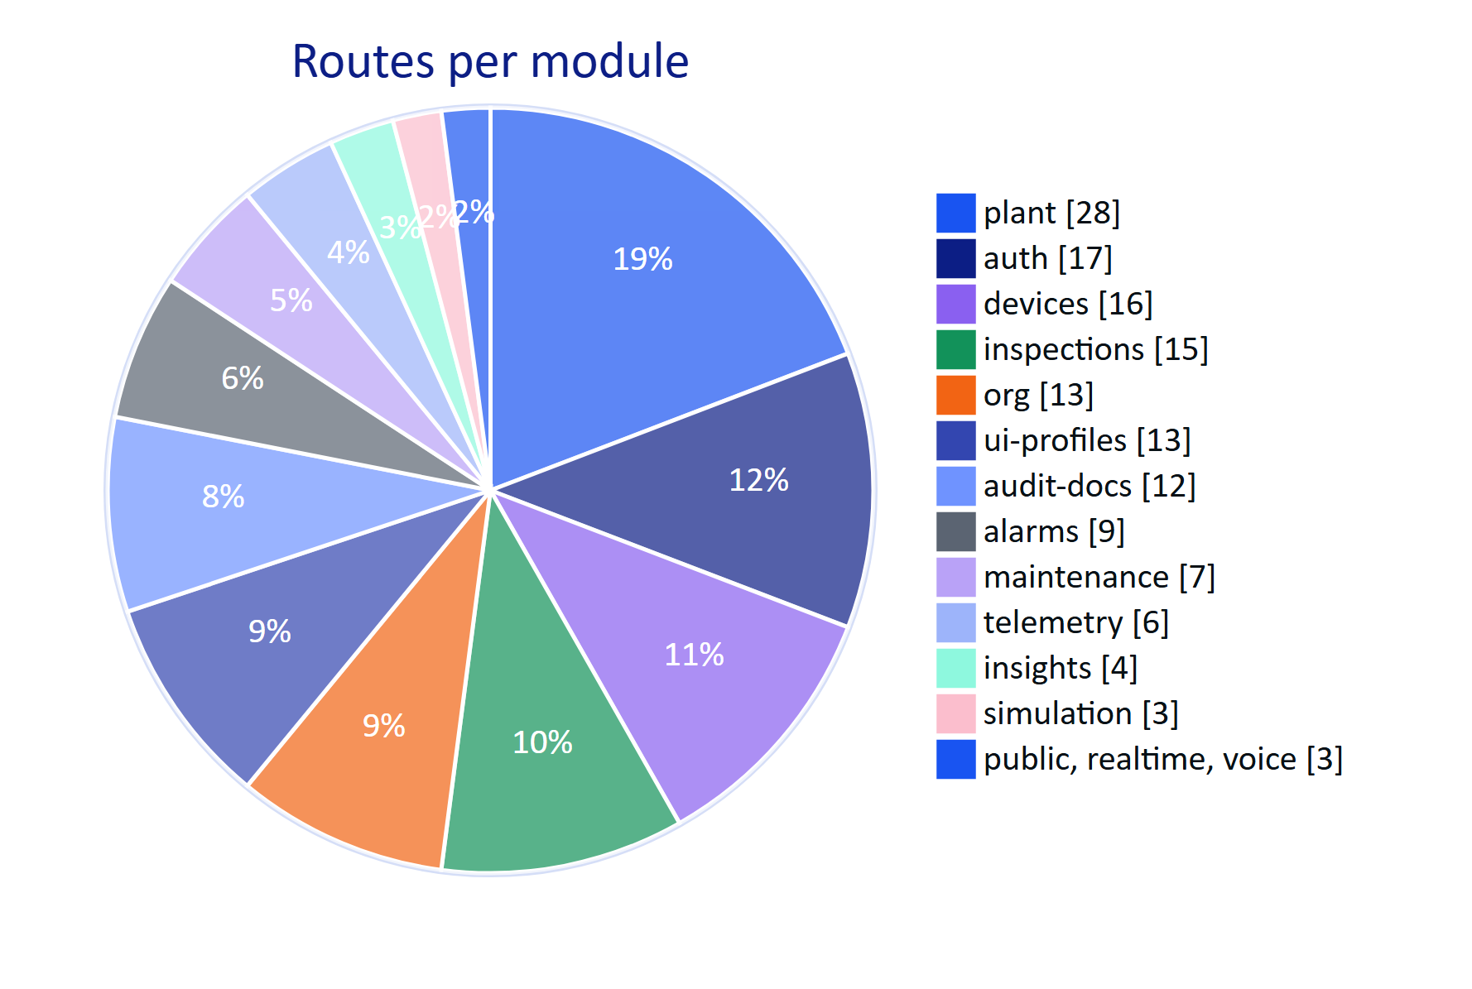
Figure 1. Routes per API module (146 module routes, counted from apps/api/src/modules)

2 Overview and conventions

2.1 Base URLs and deployment shapes
The API is served at the same origin as the console. Browsers, the glasses app and the Android app call relative or absolute /api/... paths, never a separate API host.
Table 2. Base URLs by environment
Environment | Base URL | How the API runs
Live demo | https://hydrisview.vercel.app/api | Next.js route handler apps/web/src/app/api/[...path]/route.ts forwards each request in-process to Fastify with app.inject (no network hop). Demo mode: in-memory database per serverless instance
Vercel production | https://<your-deployment>/api | Same in-process route handler, Postgres via DATABASE_URL, REALTIME_MODE=db, Vercel Blob for attachments
Local development | http://localhost:3000/api | Next.js proxies /api to the Fastify server on port 4000 (API_PORT)
Standalone API | http://<host>:4000/api | apps/api/src/server.ts, long-running process with in-memory event bus and interval jobs

Two paths are served by dedicated Next.js route handlers rather than by the catch-all forwarder: the SSE stream (apps/web/src/app/api/events/stream/route.ts) and the cron entry (apps/web/src/app/api/cron/route.ts). The Fastify app also registers GET /api/events/stream for long-running deployments; both implementations apply the same authorization function canReceive from apps/api/src/modules/realtime.ts.
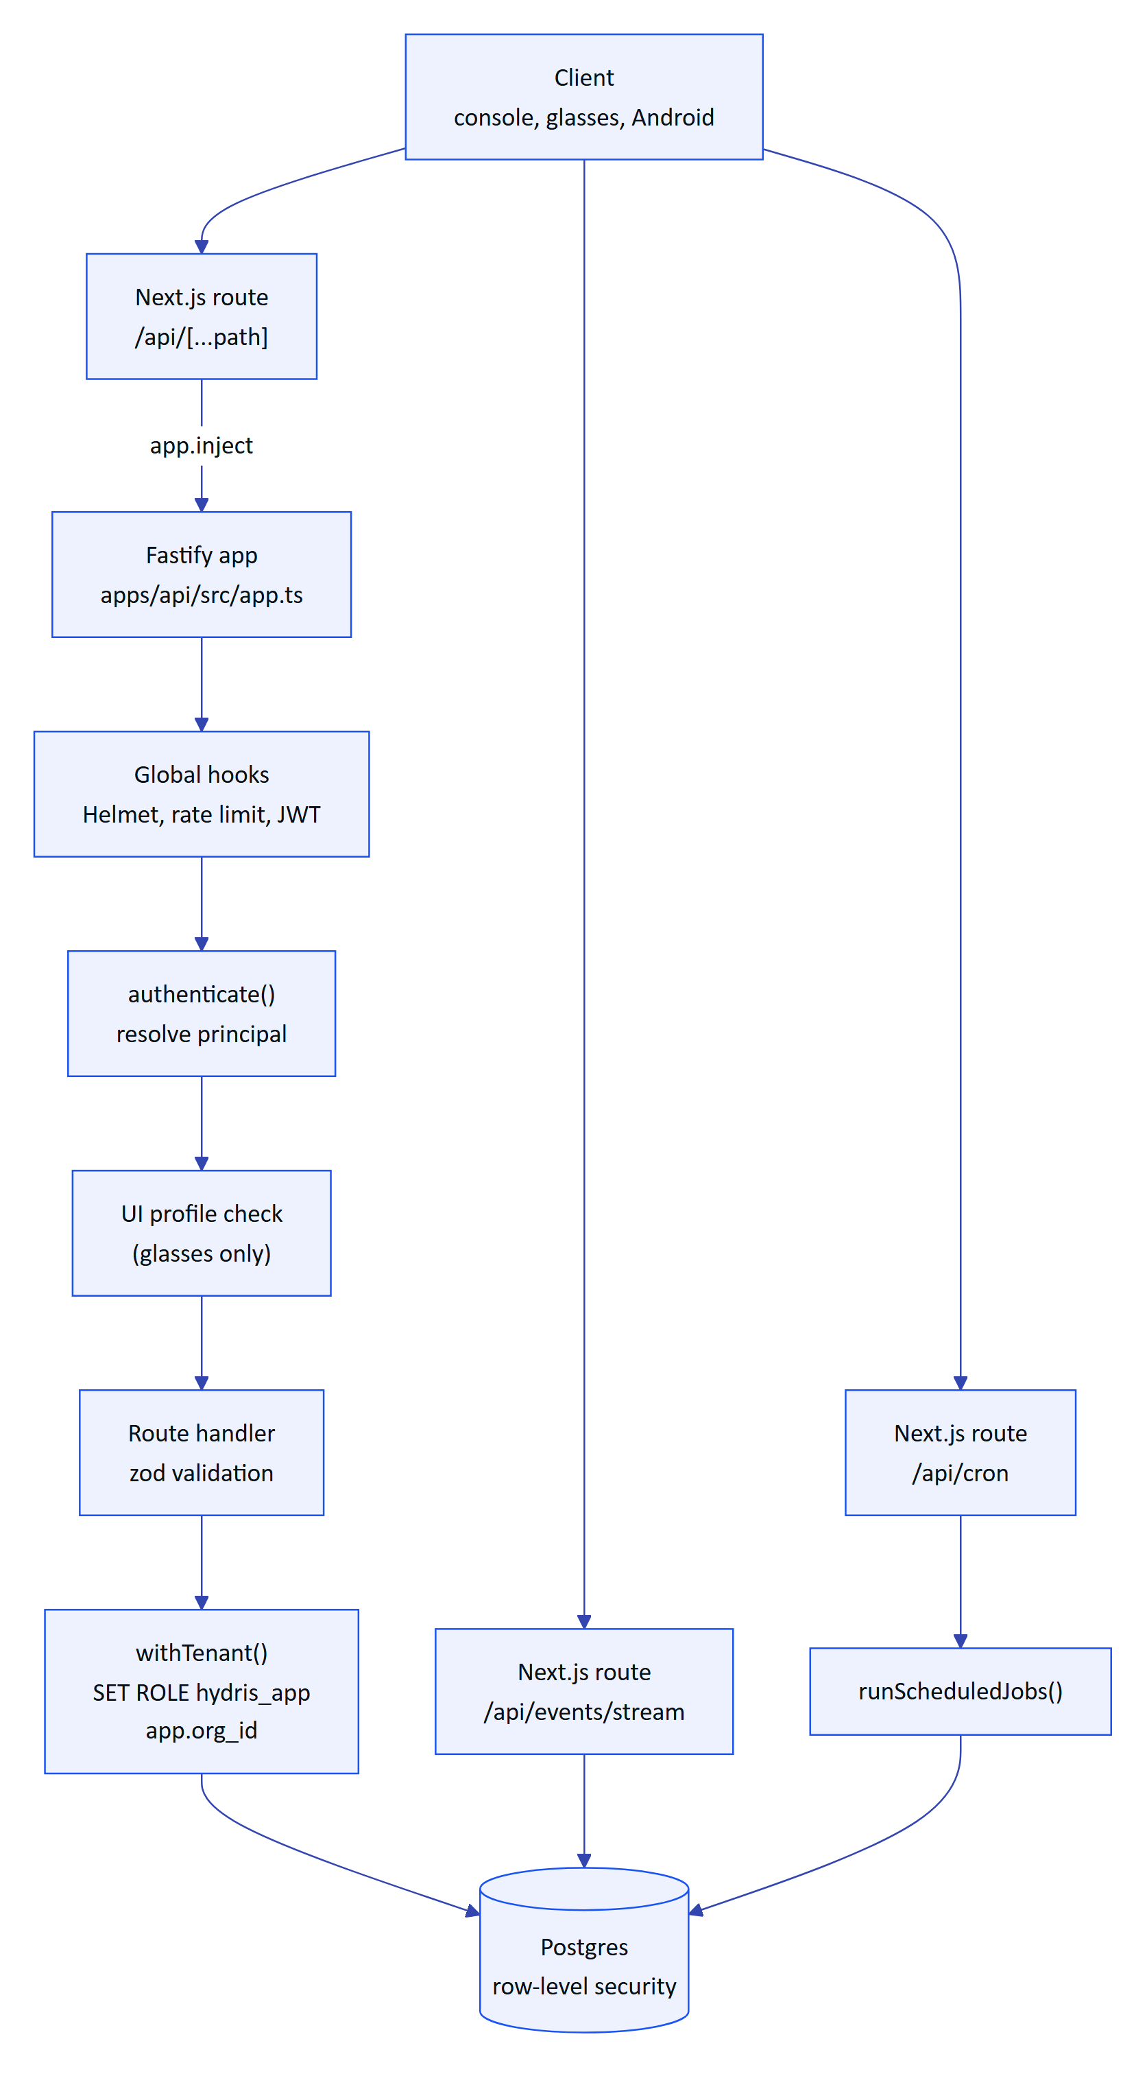
Figure 2. Request path on Vercel: the Next.js route forwards to Fastify in-process, and every tenant query runs under RLS

2.2 Versioning
The API is versioned as a whole with the product; there is no version segment in most paths. The one exception is the edge ingestion endpoint POST /api/ingest/v1/readings, which carries v1 because gateway firmware is deployed in the field and upgrades slowly. The console, glasses app and Android app ship from the same repository as the API, so breaking changes to unversioned routes are made in the same commit as the client changes. The deprecation policy for routes that third parties may depend on is described in the chapter on change history.

2.3 Content types
Table 3. Content types accepted and produced
Direction | Content type | Where
Request | application/json | Every JSON route. Global body limit 1 MB (bodyLimit in app.ts)
Request | application/json up to 8 MB | POST /api/audit-docs (base64 page images)
Request | multipart/form-data | POST /api/attachments: one file, at most 10 MB
Response | application/json | Default for every route
Response | text/csv; charset=utf-8 | Sensor export, report exports
Response | application/pdf | Searchable audit document PDF
Response | image/jpeg, image/png, image/webp, text/plain | Attachment and audit page downloads (stored MIME type)
Response | text/event-stream; charset=utf-8 | GET /api/events/stream

Send content-type: application/json with every JSON body. Action endpoints that take an optional body (for example POST /api/alarms/:id/acknowledge) accept an empty object {}; the clients always send one.

2.4 Identifiers
Every entity identifier is a UUID (version 4, generated by Postgres defaultRandom()), with three exceptions: telemetry reading ids and realtime event ids are 64-bit integers (bigint identity columns), and checklist item ids inside a maintenance task are 8-character strings. Path parameters named :id are validated with z.uuid() and a malformed id returns 400 validation_failed, not 404.
Human-facing codes are separate from ids. Site codes, facility codes, process area codes, asset tags and sensor tags are 1 to 24 characters of letters, digits, dot, dash or underscore, unique within their scope. Pairing codes are eight characters from the alphabet 23456789ABCDEFGHJKMNPQRSTVWXYZ and are displayed as XXXX-XXXX.

2.5 Timestamps and time zones
Timestamps in responses are ISO 8601 strings in UTC with millisecond precision, for example 2026-10-22T08:14:03.512Z. Timestamps in requests are accepted in two forms:
- Fields validated with z.iso.datetime({ offset: true }) (telemetry ts, inspection recordedAt) require an ISO 8601 string and accept an explicit offset such as +05:30. Timestamps more than 5 minutes in the future are rejected.
- Query parameters and date fields validated with z.coerce.date() (from, to, dueAt, before) accept anything JavaScript's Date parses. Send ISO 8601 to avoid ambiguity.
Sites and organizations carry an IANA timezone for display; the API never converts timestamps into local time.

2.6 Lists, filtering and pagination
List endpoints return a named array inside an object ({ "alarms": [...] }), with one exception: GET /api/audit-docs returns a bare array. Most lists are bounded rather than paginated, because operational lists are small and are always filtered by site scope.
Table 4. List bounds and pagination styles
Style | Endpoints | Parameters
Fixed cap | Inspections (300), maintenance (300), audit documents (200), notifications (50), device context sections (20) | None
Limit | Alarms | limit 1 to 500, default 200
Limit and time cursor | Audit log | limit 1 to 500, default 100, plus before (exclusive timestamp cursor)
Limit and offset | Sensor readings | limit 1 to 200, default 50, offset 0 to 1,000,000, response carries total
Downsampling | Sensor history | points 10 to 2000, default 240: the server buckets readings with date_bin
Range | Reports, CSV export | from and to. Reports default to the last 30 days and cap at 5000 rows; sensor CSV export spans at most 93 days

Boolean query parameters are strings: "true" or "false". Enumerated filters reject unknown values with 400 validation_failed.

2.7 Tenancy and site scope
Every authenticated request carries exactly one organization: the org claim of a user token or the organization of the paired device. The handler opens a transaction with withTenant() (apps/api/src/db/tenant.ts), which switches to the non-privileged hydris_app role and sets app.org_id, so RLS policies hide every other tenant's rows even if a query forgets a filter.
Inside a tenant, members are either organization-wide (allSites: true) or limited to a list of sites. Site scope is enforced in the handlers with siteScope(), requireSite() and scopedRow() from apps/api/src/core/principal.ts. A record outside the caller's sites returns 404 not_found, never 403, so a caller cannot probe which ids exist.

3 Authentication and sessions
Hydris has four credential types. Console users hold a short-lived bearer access token plus a rotating refresh cookie. Paired glasses hold a device access token plus a rotating device refresh token. Edge gateways hold a static API key. The Vercel cron caller holds a shared secret. All implementations live in apps/api/src/modules/auth.ts, apps/api/src/modules/devices.ts, apps/api/src/context.ts and apps/api/src/config.ts.
Table 5. Credential types
Credential | Format | Lifetime | Transport | Issued by
User access token | JWT, claims typ: "user", sub (user id), org, sid (session family) | 15 minutes, 12 hours in demo mode | Authorization: Bearer | Login, MFA verify, demo login, refresh, switch org, invitation accept, password change
User refresh token | 48 random bytes, base64url, stored as SHA-256 hash in auth_sessions | 7 days, rotated on every refresh | Cookie hg_refresh, httpOnly, SameSite=Strict, Secure in production, path /api/auth | Same as above
Demo session cookie | JWT, typ: "demo_session" | 7 days | Cookie hg_demo, same attributes | Demo mode only
MFA challenge token | JWT, typ: "mfa", sub | 5 minutes | JSON body | POST /api/auth/login when MFA is enabled
Device access token | JWT, claims typ: "device", sub (device id), org, sv (session version); demo mode adds uid and site | 15 minutes, 12 hours in demo mode | Authorization: Bearer | Pairing completion, device refresh
Device refresh token | hgd_ plus 40 random bytes (demo mode: hgd_z plus an HMAC-signed body) | 30 days, rotated on every refresh | JSON body of POST /api/device/refresh | Same as above
Gateway API key | hgw_ plus 32 random bytes, stored as SHA-256 hash with a 10-character prefix | Until revoked | Authorization: Bearer hgw_... | POST /api/gateways (shown once)
Cron secret | Value of CRON_SECRET | Until rotated | Authorization: Bearer <CRON_SECRET> | Deployment configuration

Access tokens are signed with JWT_SECRET (at least 32 characters) through @fastify/jwt. Every request re-checks revocation state in the database: for a user token the session family must still have a non-revoked row and the membership and organization must be active; for a device token the device must be active, its sessionVersion must equal the token's sv claim, and an operator must still be assigned. Revoking a session family or bumping a device's session version therefore invalidates outstanding access tokens immediately, not when they expire.

3.1 Password sign-in
POST /api/auth/login verifies the password with argon2id (memory 19,456 KiB, 2 iterations). Unknown emails burn the same verification time against a dummy hash so response timing does not reveal which emails exist. Five consecutive failures lock the account for 15 minutes (423 account_locked). A successful login picks the user's default organization (or the first active membership), writes an auth.login audit event, stores a refresh session and returns the session view.
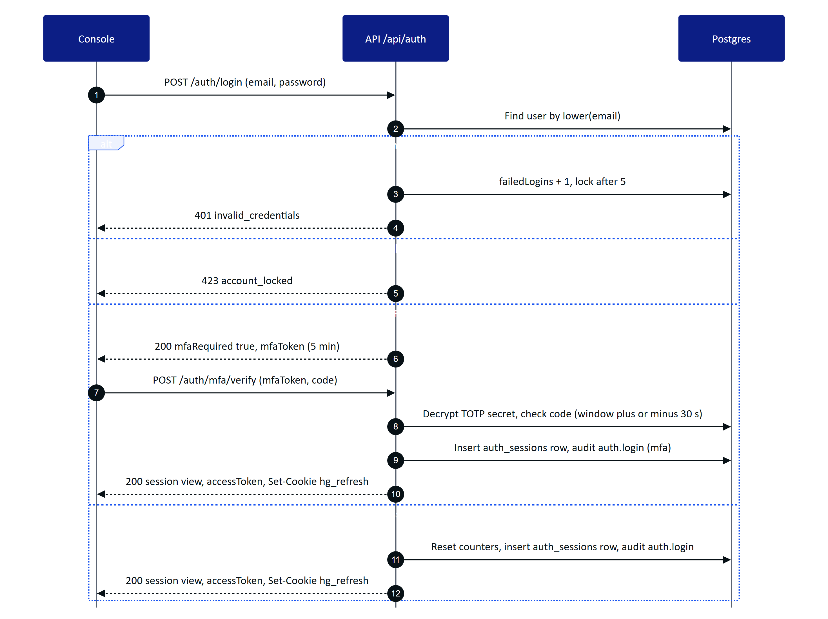
Figure 3. Password sign-in, with the MFA branch taken when the user has TOTP enabled
The session view returned by login, MFA verify, demo login, refresh, switch org, password change and invitation accept has the same shape:
{
"accessToken": "eyJhbGciOiJIUzI1NiIsInR5cCI6IkpXVCJ9...",
"user": { "id": "7c1e...", "name": "Tarun KM", "email": "tarun@hydris.ai", "isPlatformAdmin": false, "mfaEnabled": false },
"memberships": [
{ "orgId": "0b6f...", "orgName": "Hydris Demo Utilities", "role": "org_admin", "isDemo": true, "allSites": true }
],
"org": { "id": "0b6f...", "name": "Hydris Demo Utilities", "isDemo": true },
"role": "org_admin",
"permissions": ["org.manage", "site.read", "site.manage", "..."],
"siteScope": "all"
}
siteScope is the string "all" for organization-wide members and an array of site ids otherwise. permissions is the full list for the active role; clients use it only to decide what to show, the API re-checks on every call.

3.2 Multi-factor authentication
MFA is TOTP (RFC 6238: SHA-1, 30-second step, 6 digits, one step of clock tolerance either side). Enrolment is two calls: POST /api/auth/mfa/setup generates a 20-byte secret, stores it encrypted with AES-256-GCM under DATA_KEY and returns the secret and an otpauth:// URI for an authenticator app; POST /api/auth/mfa/enable turns MFA on once the user proves a valid code. POST /api/auth/mfa/disable needs both the password and a current code. When MFA is on, POST /api/auth/login returns { "mfaRequired": true, "mfaToken": "..." } instead of a session, and the client completes sign-in with POST /api/auth/mfa/verify.

3.3 Demo sign-in
The live demo runs in demo mode (DEMO_MODE=true, or automatically on Vercel when DATABASE_URL is unset). In demo mode POST /api/auth/demo with a name creates a named guest account in the synthetic demo tenant. The account id is derived deterministically from the normalized name (guestUserId() in apps/api/src/core/demo-guests.ts), so the same name always maps to the same account, and the guest receives a personal copy of the demo owner's open inspections and maintenance tasks. Guests are organization administrators of the demo tenant with access to all sites.
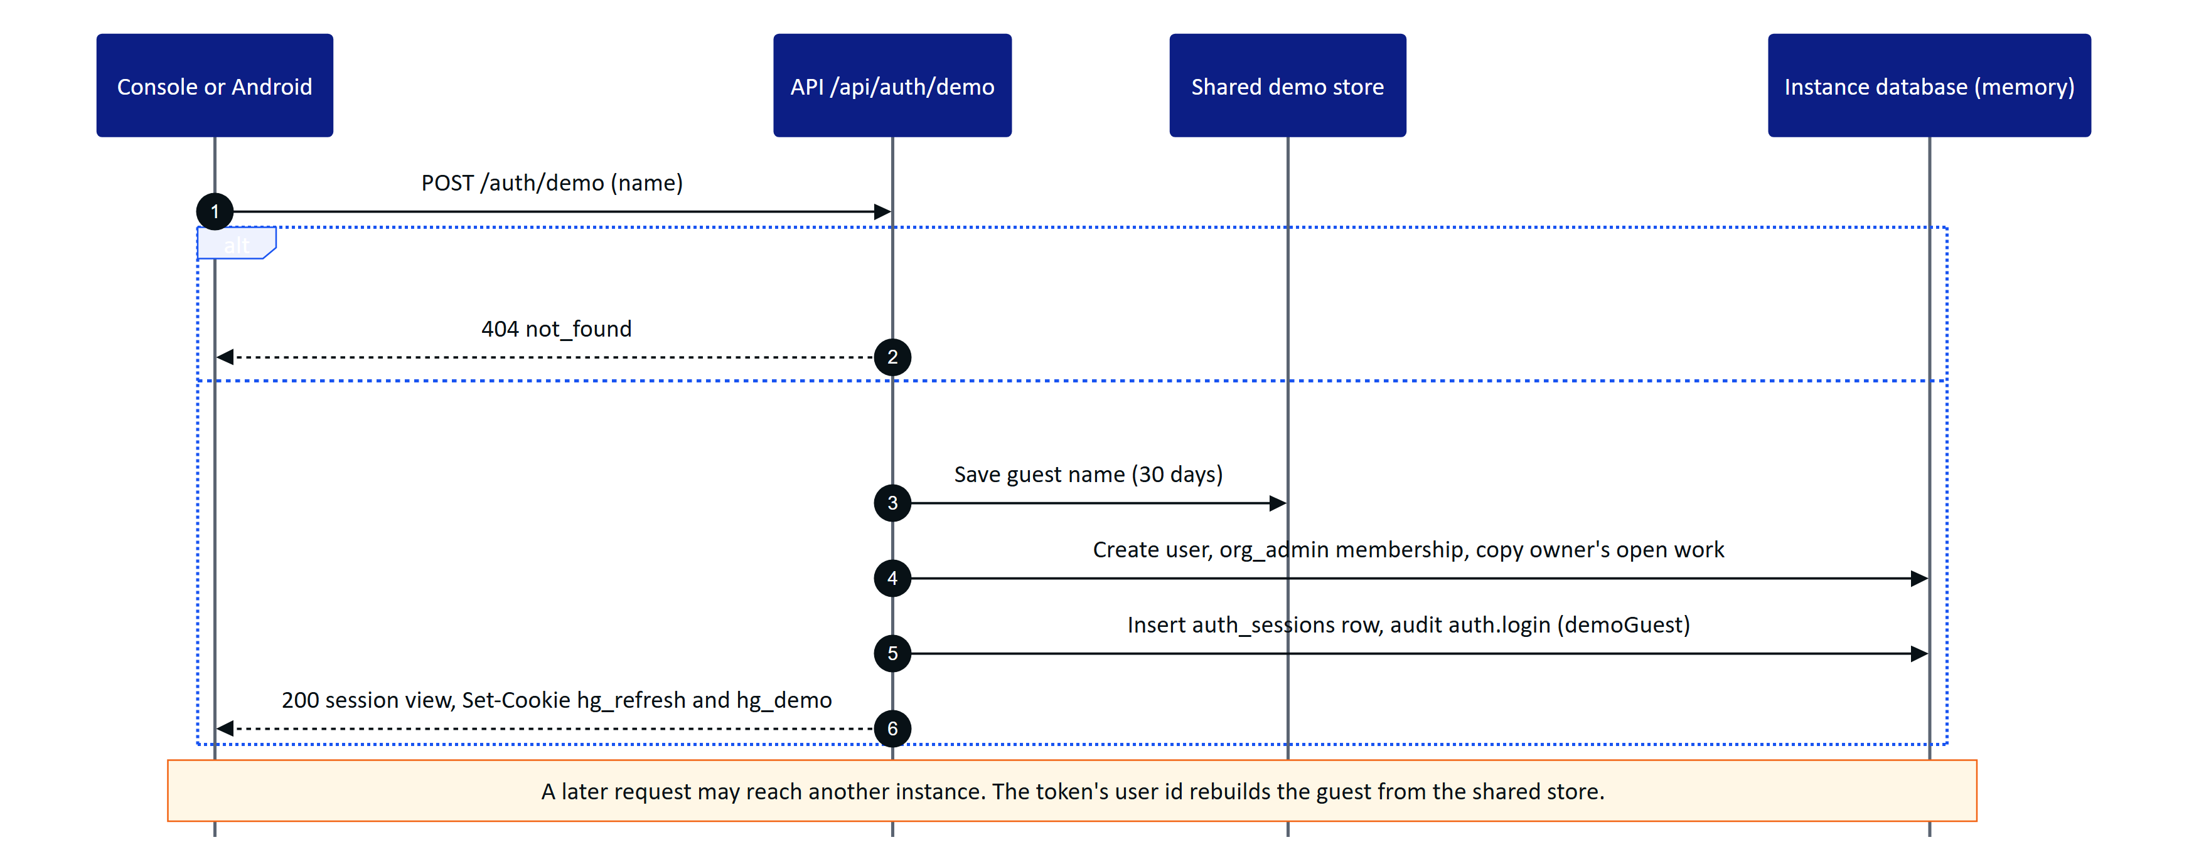
Figure 4. Demo sign-in creates or reuses a named guest and starts a normal session plus a signed demo cookie
Because each serverless instance in demo mode has its own in-memory database, demo mode relaxes three stateful checks (documented in apps/api/src/demo.ts): a user access token whose session family is unknown on the instance is accepted (a family that is known and revoked is still rejected); POST /api/auth/refresh falls back to the signed hg_demo cookie and re-creates the session family locally; and device tokens carry the operator and site so any instance can rebuild the device record.
WARNING
Demo mode uses fixed public secrets (DEMO_SECRETS in apps/api/src/config.ts) when JWT_SECRET and DATA_KEY are not configured. It exists for the synthetic demo tenant only and must never serve a real plant.

3.4 Refresh and rotation
POST /api/auth/refresh reads the hg_refresh cookie, marks the presented session row as rotated, and issues a new row in the same family with a new cookie and a new access token. Rotation detects theft: if a refresh token that was already rotated is presented again more than 30 seconds after its rotation, the API revokes the whole family, writes auth.refresh_reuse_detected and returns 401 session_revoked. Inside the 30-second grace window a replay issues another successor instead, which keeps several open tabs that refresh at the same moment from logging each other out.
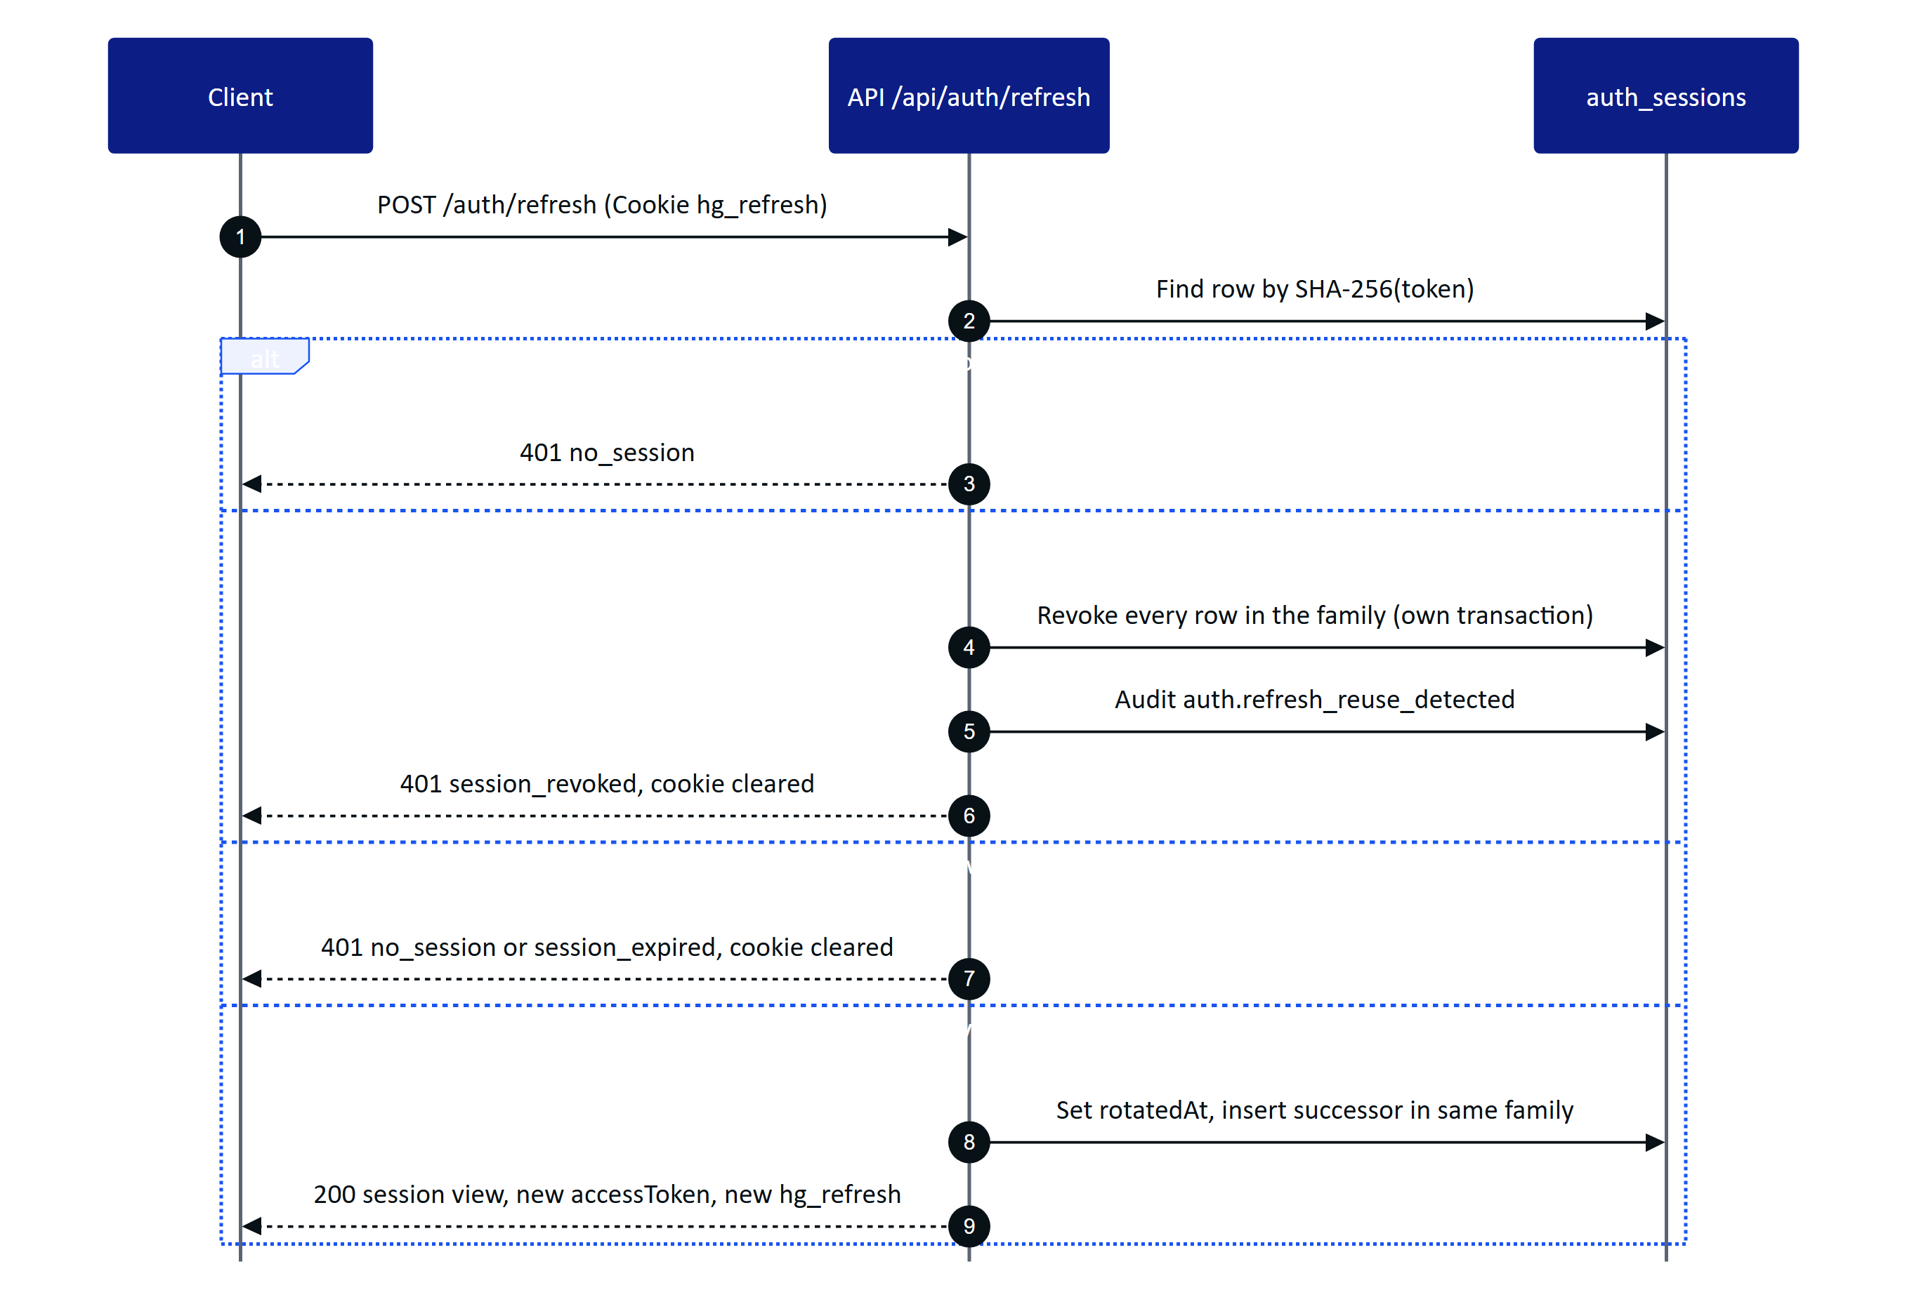
Figure 5. Refresh token rotation with a 30-second reuse grace window and family-wide revocation on replay
The web client (apps/web/src/lib/api.ts) and the Android client (HydrisApi.kt) both serialize refreshes so that a burst of parallel 401 responses triggers one refresh call.

3.5 Glasses pairing
Glasses never see a user password. Pairing follows the shape of the OAuth 2.0 Device Authorization Grant (RFC 8628). The glasses request a challenge and display a short user code and a QR code that encodes only the verification URL with that code. A signed-in person approves the code on a phone or console, choosing the site and (with device.manage) the operator. The glasses, which hold a separate poll secret that is never displayed, poll until the challenge is approved and then receive device credentials exactly once.
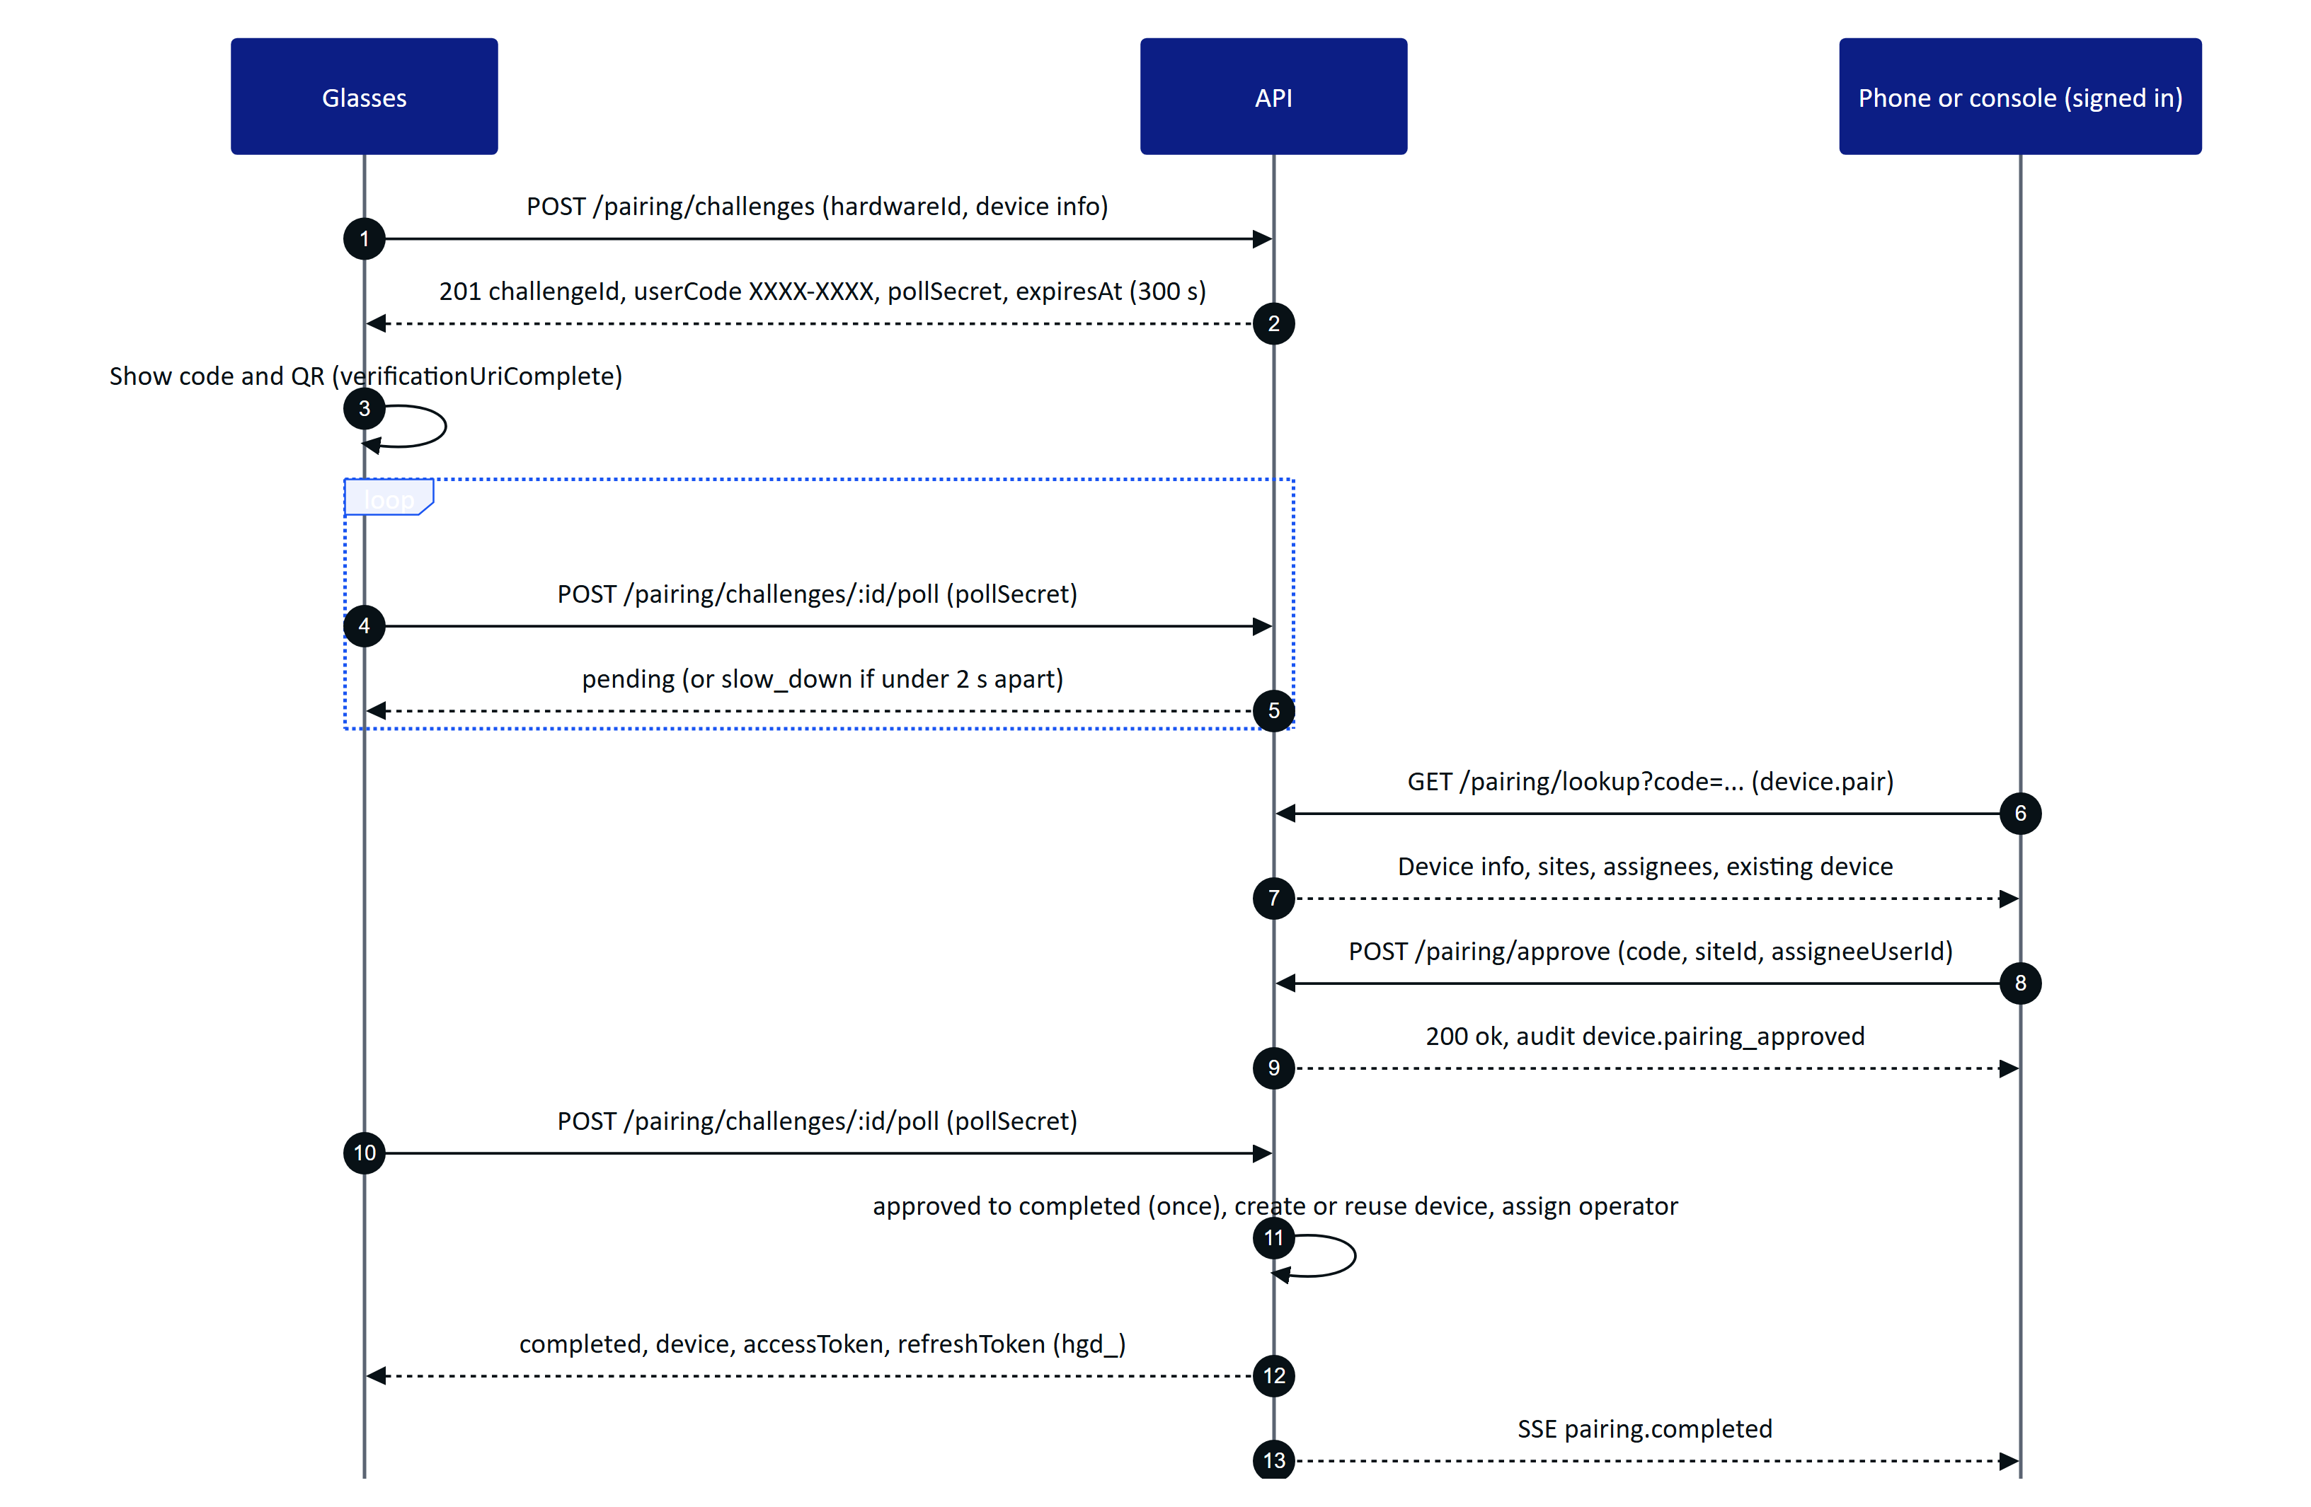
Figure 6. Glasses pairing in the shape of RFC 8628: code on the glasses, approval by a signed-in person, single-use claim
Security properties of the flow, all implemented in apps/api/src/modules/devices.ts:
- The code is drawn with a CSPRNG from a 30-character unambiguous alphabet, stored only as a SHA-256 hash, valid for 300 seconds and usable once. Code lookups and approvals are limited to 10 per minute per IP.
- The poll secret (32 random bytes) is stored as a hash and compared in constant time; a wrong secret returns 404.
- Requesting a new challenge from the same hardwareId cancels any open challenge from that install.
- Glasses registered to another organization cannot be approved until revoked there (409 device_owned_elsewhere).
- Re-pairing the same install within the same organization reuses the device record, bumps its session version and revokes its previous device sessions.
- A background job marks pending and approved challenges past their expiry as expired.

3.6 Device token refresh
POST /api/device/refresh exchanges a device refresh token for a new access token and a new refresh token. Unlike user refresh there is no grace window: presenting a device refresh token that was already rotated revokes the entire device session family, writes device.refresh_reuse_detected and returns 401 device_session_invalid. The glasses then need to be paired again.
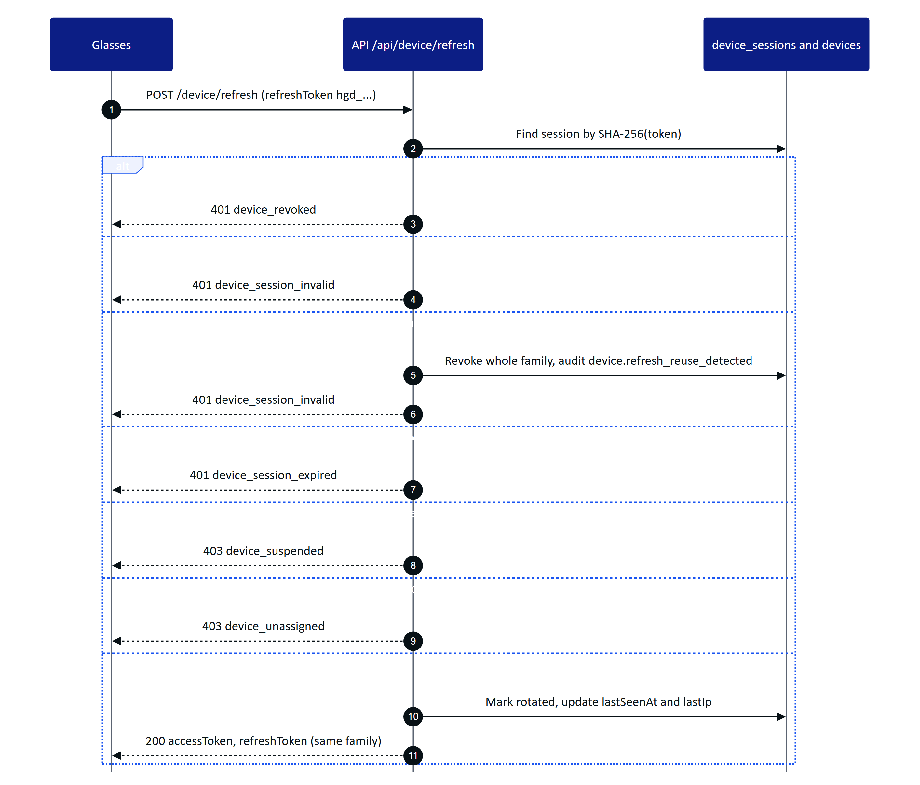
Figure 7. Device refresh rotation, with revocation, suspension and unassignment checks

3.7 Ending sessions
Sessions end in several ways, and each one is enforced on the very next request because principals are re-resolved from the database on every call and every 30 seconds on open SSE streams.
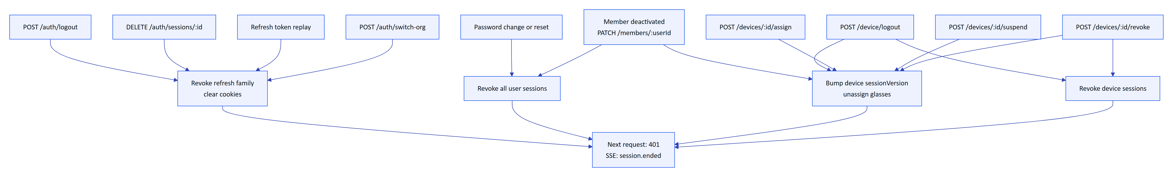
Figure 8. Every way a user or device session ends, and the mechanism that enforces it
POST /api/device/logout is the glasses-initiated unpair: it revokes the device's refresh sessions and bumps its session version, so the same glasses can be paired again by anyone. Console-initiated revocation (POST /api/devices/:id/revoke) is final for that device record: it also releases the operator assignment, and the glasses must pair again to obtain a new credential.

4 Authorization
Authorization has four layers, applied in this order on every authenticated route:
- Authentication. authenticate(ctx) resolves the bearer token into a principal (user or device) or returns 401 unauthenticated.
- Role permission. requirePerm(p, permission) checks the role matrix in packages/domain/src/roles.ts. For device principals the permission must also be in DEVICE_PERMISSIONS (apps/api/src/core/principal.ts), so a paired glasses device can never do more than its operator, and never anything administrative. Failure returns 403 forbidden.
- Site scope. Records on sites outside the principal's scope return 404 not_found.
- Glasses UI profile. For device principals only, a hook installed by installProfileEnforcement() (apps/api/src/modules/ui-profiles.ts) checks that the device's effective UI profile enables the screen and action the route serves. Failure returns 403 profile_forbidden.
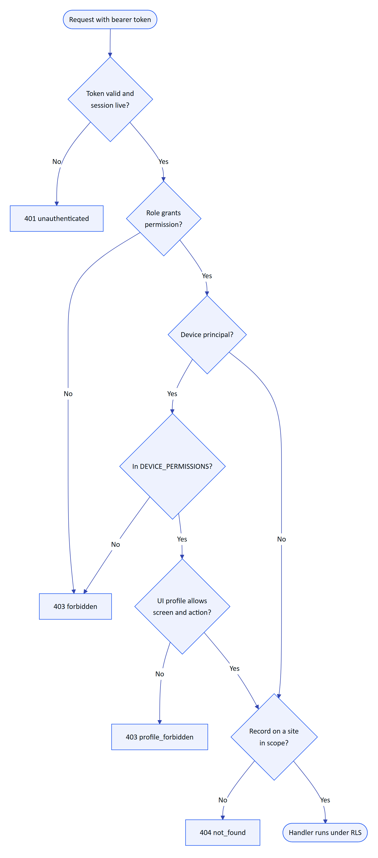
Figure 9. Authorization decision for an authenticated request
Some rules are expressed in the handler rather than as a single permission. The most important ones: inspections are recorded only by their assignee and reviewed only by someone else; audit documents are approved by a different person from the verifier (except in demo tenants, where self-approval is recorded as such); maintenance executors can start, hold and complete only tasks assigned to them; and members can grant only roles listed by assignableRoles() (organization administrators grant any role, factory managers grant supervisor, field operator, maintenance engineer and viewer).

4.1 Role and permission matrix
Table 6. Permissions by role (Y = granted). The last column marks the 13 permissions a paired glasses device may use on behalf of its operator
Permission | Org admin | Factory manager | Supervisor | Field operator | Maintenance engineer | Viewer | Glasses
org.manage | Y
site.read | Y | Y | Y | Y | Y | Y | Y
site.manage | Y | Y
asset.read | Y | Y | Y | Y | Y | Y | Y
asset.manage | Y | Y
sensor.manage | Y | Y
telemetry.read | Y | Y | Y | Y | Y | Y | Y
gateway.manage | Y | Y
alarm.read | Y | Y | Y | Y | Y | Y | Y
alarm.acknowledge | Y | Y | Y | Y | Y |  | Y
alarm.assign | Y | Y | Y
alarm.investigate | Y | Y | Y |  | Y
alarm.resolve | Y | Y | Y |  | Y
alarm.close | Y | Y | Y
alarm_rule.manage | Y | Y
inspection.read | Y | Y | Y | Y | Y | Y | Y
inspection.manage | Y | Y | Y
inspection.execute | Y |  | Y | Y | Y |  | Y
inspection.review | Y | Y | Y
maintenance.read | Y | Y | Y | Y | Y | Y | Y
maintenance.request | Y | Y | Y | Y | Y |  | Y
maintenance.manage | Y | Y | Y
maintenance.execute | Y |  |  |  | Y |  | Y
member.read | Y | Y | Y
member.manage | Y | Y
device.read | Y | Y | Y
device.pair | Y | Y | Y | Y | Y
device.manage | Y | Y
document.read | Y | Y | Y | Y | Y | Y | Y
document.manage | Y | Y
report.read | Y | Y | Y |  |  | Y
report.export | Y | Y | Y
audit.read | Y | Y
simulation.control | Y | Y
auditdoc.read | Y | Y | Y | Y | Y | Y | Y
auditdoc.capture | Y | Y | Y | Y | Y |  | Y
auditdoc.verify | Y | Y | Y
auditdoc.approve | Y | Y

The glasses column is an upper bound: a device holds the intersection of this column and its operator's role. Glasses assigned to a viewer, for example, cannot acknowledge alarms. Factory managers deliberately lack inspection.execute and maintenance.execute: they plan and review work rather than record it.
NOTE
Platform administration (/api/platform/*) is outside the role matrix. It requires users.isPlatformAdmin, which is resolved from the user token even when the user has no membership in any organization.

5 Errors

5.1 Error envelope
Every error produced by the API has the same JSON envelope. The error handler is registered in apps/api/src/app.ts; handlers throw HttpError (apps/api/src/core/errors.ts) and zod throws ZodError.
{
"error": {
"code": "validation_failed",
"message": "Some fields are invalid",
"details": [
{ "path": "readings.0.ts", "message": "Invalid ISO datetime" }
]
}
}
- code is stable and machine-readable. Clients branch on code, never on message.
- message is a human-readable sentence suitable for display. It may change between releases.
- details is optional. For validation_failed it is an array of { path, message } with dotted paths; a few handler errors put a structured object here instead (for example the inspection progress on incomplete, or the current state on invalid_transition).
Errors that do not originate in a handler are mapped as follows: a status of 429 becomes rate_limited; any status of 500 or more becomes internal_error with the message "Unexpected server error" (the real error is logged, never returned); other Fastify errors keep their own code (for example FST_ERR_CTP_BODY_TOO_LARGE with status 413).
NOTE
Requests to a path that matches no route are answered by Fastify's default not-found handler, which does not use the Hydris envelope. The Next.js route handlers have their own failure codes: service_unavailable (503) when the API cannot start, internal (500) when forwarding fails, and unauthorized (401) on the cron and stream routes.

5.2 HTTP status codes
Table 7. HTTP status codes used by the API
Status | Meaning in Hydris
200 | Success with a body
201 | Resource created (invitation, site, asset, sensor, rule, inspection, task, audit document, pairing challenge, assignment)
204 | Success without a body (POST /api/device/logout)
400 | Validation failure or a business rule the request breaks (missing note, incomplete checklist, weak password)
401 | Missing, invalid, expired or revoked credential
403 | Authenticated but not permitted (role, device cap, UI profile, four-eyes rule)
404 | Not found, or outside the caller's site scope
409 | Conflict with current state: invalid transition, stale revision, duplicate, already used
413 | Body or file larger than the configured limit
423 | Account locked after repeated failed logins
429 | Rate limit exceeded
500 | Unexpected server error
503 | Pairing code allocation failed, or the serverless API could not start

5.3 Error code catalogue
The table lists every error.code the API emits, collected from the handlers. Codes are grouped by status.
Table 8. Error codes by HTTP status
Status | Code | Raised by | Meaning
400 | validation_failed | All routes (zod), plus asset, sensor, rule, document and maintenance edits | Body, query or path parameters are invalid. details lists each field
400 | weak_password | Change password, reset, invitation accept | Fewer than 12 characters, more than 200, or one repeated character
400 | wrong_password | Change password, MFA disable, invitation accept | Current password is incorrect
400 | invalid_token | Password reset complete | Reset link invalid, used or expired (30 minutes)
400 | invalid_invitation | Invitation preview and accept | Invitation invalid, used, revoked or expired (7 days)
400 | invalid_mfa_code | MFA enable and disable | TOTP code is not valid
400 | mfa_already_enabled | MFA setup | MFA is already on
400 | sites_required | Create invitation | allSites is false and no site was chosen
400 | invalid_sites | Create invitation | A site id does not exist in the organization
400 | forbidden_scope | Create site, document scope | Only organization-wide managers may do this
400 | invalid_process_area | Create asset | Process area is not in the asset's facility
400 | file_required | Upload attachment | No file part in the multipart body
400 | unsupported_type | Upload attachment | MIME type is not JPEG, PNG, WebP, PDF or plain text
400 | content_mismatch | Upload attachment | File signature does not match the declared MIME type
400 | method_mismatch | Manual reading | Lab entry against an online (continuous) instrument
400 | reading_rejected | Manual reading | The ingestion pipeline rejected the value; details.reason gives why
400 | invalid_range | Sensor history, reports | from is not before to
400 | range_too_large | Sensor CSV export | More than 93 days requested
400 | note_required | Alarm resolve, inspection reject, maintenance complete | A note is mandatory for this transition
400 | invalid_assignee | Alarms, inspections, maintenance, devices, pairing | Assignee is not an active member, or cannot execute inspections
400 | assignee_no_site_access | Pairing approve | The chosen operator has no access to the chosen site
400 | threshold_required | Create alarm rule | Non-stale rules need a threshold
400 | invalid_template | Create inspection | Template missing or not published
400 | invalid_asset | Create inspection | Asset not found
400 | invalid_assets | Inspection routes | A route stop is not an asset on the route's site
400 | site_required | Create inspection, create maintenance task | Neither an asset nor a site was given
400 | incomplete | Inspection submit | Required steps are unanswered; details carries the progress object
400 | invalid_alarm | Create maintenance task | sourceAlarmId does not exist
400 | checklist_incomplete | Maintenance complete | Checklist items are still open
400 | reason_required | Device revoke, audit document reject | A reason is mandatory
400 | invalid_code | Pairing lookup and approve | Code is not 8 valid characters
400 | page_too_large | Audit document capture | A page image is over 900 KB
400 | invalid_image | Audit document capture | Page bytes are not a JPEG or PNG
400 | value_required | Audit item correct | Corrected field value missing
400 | rows_required | Audit item correct | Corrected table rows missing
400 | flagged_items | Audit document verify | Flagged items must be resolved first
400 | review_incomplete | Audit document verify | Items are still pending review
400 | no_draft | UI profile publish | There is no draft to publish
400 | cannot_rollback_to_draft | UI profile rollback | Target version is the open draft
400 | invalid_profile, invalid_user, invalid_device | UI profile assignment | Target not found in the organization
400 | subject_required | Effective UI profile | Neither deviceId nor userId given
400 | too_fast | Public enquiry | Form submitted less than 2.5 s after it was opened
401 | unauthenticated | Every authenticated route | No token, invalid token, or session no longer live
401 | invalid_credentials | Login | Email or password incorrect (also for inactive accounts)
401 | mfa_expired | MFA verify | The 5-minute MFA token expired
401 | invalid_mfa_code | MFA verify | TOTP code is not valid
401 | no_session | Refresh | No cookie, unknown or revoked session
401 | session_expired | Refresh | Refresh session older than 7 days
401 | session_revoked | Refresh | Replay of a rotated token; whole family revoked
401 | device_revoked | Device refresh | Device revoked by an administrator
401 | device_session_invalid | Device refresh | Unknown, revoked or replayed device refresh token
401 | device_session_expired | Device refresh | Device refresh session older than 30 days
401 | invalid_gateway_key | Edge ingestion | Missing, wrong, revoked key or suspended organization
403 | forbidden | Every permission check | Role, device cap or handler rule denies the action
403 | device_suspended | Device refresh | Device is suspended
403 | device_unassigned | Device refresh | No operator assigned to the device
403 | profile_forbidden | Glasses routes | The device's UI profile disables this screen or action
404 | not_found | Every lookup | Record missing or outside site scope; /api/auth/demo outside demo mode
409 | slug_taken | Create organization | Slug already used
409 | already_member | Create invitation | Email belongs to an active member
409 | code_taken | Sites, facilities, process areas | Code already used in scope
409 | tag_taken | Assets, sensors | Tag already used
409 | source_ref_taken | Update sensor | Gateway reference already used on the site
409 | in_use | Delete asset | Asset has sensors, alarms, inspections or tasks: archive instead
409 | duplicate_reading | Manual reading | A reading already exists at that sensor and timestamp
409 | no_change | Reading correction, template status | Nothing would change
409 | already_invalidated | Reading correction | Reading is already invalidated
409 | invalid_transition | Alarms, inspections, maintenance, devices | Action not allowed from the current state
409 | stale_state | Alarm transitions, maintenance transitions | State changed between read and write
409 | revision_conflict | Inspection transitions | expectedRevision does not match, or concurrent write
409 | not_editable | Inspection and maintenance edits | Record is closed
409 | archived | Template update | Template must be restored before editing
409 | not_running | Simulation stop | No simulation is running
409 | already_used | Pairing approve | Code was approved concurrently
409 | device_owned_elsewhere | Pairing approve | Glasses registered to another organization
409 | device_not_active | Device assign | Only active devices can be reassigned
409 | device_revoked | Device suspend, reactivate, revoke | Device is already revoked
409 | review_started | Audit enhance | Human review has begun
409 | stale | Audit document writes | Revision changed underneath the caller
409 | locked | Audit document edits | Approved documents are locked
409 | not_in_review | Audit confirm-agreed and verify | Document is not in review
409 | not_verified | Audit approve | Document must be verified first
409 | profile_archived | UI profile draft and publish | Archived profiles cannot change
409 | profile_assigned | UI profile archive | Remove assignments first
409 | already_published | UI profile rollback | Target version is already live
413 | FST_ERR_CTP_BODY_TOO_LARGE | Any JSON route | Body over 1 MB (8 MB for audit capture)
423 | account_locked | Login | Five failed attempts; locked 15 minutes
429 | rate_limited | Any route | Rate limit exceeded
500 | internal_error | Any route | Unexpected error (logged server-side)
503 | pairing_unavailable | Pairing challenge | No unique code after five attempts

6 Rate limiting
Rate limits use @fastify/rate-limit, keyed by client IP. Fastify runs with trustProxy: true, and the Vercel route handler passes the first x-forwarded-for address as the remote address, so the key is the real client IP rather than the platform's proxy. A global limit of 600 requests per minute applies to every route; the routes below set a stricter limit of their own.
Table 9. Route-specific rate limits
Route | Limit | Window | Reason
POST /api/auth/login | 10 | 1 minute | Credential stuffing
POST /api/auth/mfa/verify | 10 | 1 minute | TOTP guessing
POST /api/auth/demo | 20 | 1 minute | Guest creation
POST /api/auth/refresh | 60 | 1 minute | Token churn
POST /api/auth/password-reset/request | 5 | 1 minute | Mail abuse, enumeration
POST /api/auth/password-reset/complete | 10 | 1 minute | Token guessing
GET /api/auth/invitations/:token | 30 | 1 minute | Token probing
POST /api/auth/invitations/accept | 10 | 1 minute | Token guessing
POST /api/pairing/challenges | 10 | 1 minute | Code exhaustion
POST /api/pairing/challenges/:id/poll | 40 | 1 minute | Polling every 3 s with headroom
POST /api/pairing/challenges/:id/cancel | 20 | 1 minute
GET /api/pairing/lookup | 10 | 1 minute | Pairing code guessing
POST /api/pairing/approve, POST /api/pairing/deny | 10 | 1 minute | Pairing code guessing
POST /api/device/refresh | 30 | 1 minute | Token churn
POST /api/assistant/ask | 60 | 1 minute | Language model cost
POST /api/ingest/v1/readings | 1200 | 1 minute | Gateway throughput (each call carries up to 500 readings)
POST /api/public/inquiries | 5 | 10 minutes | Website form spam
All other routes | 600 | 1 minute | Global ceiling

When a limit is exceeded the API returns 429 rate_limited. The plugin also sets its standard rate limit headers on responses (limit, remaining and reset, plus retry-after on 429); clients should back off for the indicated time. Tests build the app with relaxedLimits, which raises every limit except the assistant's.
WARNING
The rate limit store is the plugin's in-process memory store. On Vercel each serverless instance counts separately, so the effective limit across a burst that fans out to several instances is a multiple of the configured value. A shared store (Redis or Postgres) is needed before the limits can be treated as hard guarantees.

The pairing poll endpoint has a second, application-level throttle: polling the same challenge again less than two seconds after the previous poll returns { "status": "slow_down", "pollIntervalS": 3 } without consuming the approval.

7 Idempotency and concurrency
Hydris does not use a generic Idempotency-Key header. Instead each write that can be retried by an intermittently connected client is idempotent by design, and each write that races with other people uses optimistic concurrency.
Table 10. Idempotency and concurrency mechanisms
Operation | Mechanism | Replay or race outcome
Edge ingestion | Unique (sensor_id, ts) on telemetry_readings | A repeated reading counts in duplicates, nothing is stored twice
Manual reading | Same unique key | 409 duplicate_reading: correct the existing reading instead
Inspection step responses | Client-generated opId (8 to 80 characters), unique per inspection | Replayed ops count in duplicates
Inspection transitions | revision counter, optional expectedRevision in the body | 409 revision_conflict
Alarm transitions | WHERE state = <state read> on update | 409 stale_state
Maintenance transitions | WHERE status = <status read> on update | 409 stale_state
Audit document writes | revision counter, optional expectedRevision | 409 stale
Pairing claim | approved to completed update guarded by status | Second claim returns completed with error: "already_claimed" and no tokens
Pairing approve | pending to approved update guarded by status | 409 already_used
UI profile assignment | One assignment per org, role, user or device | Re-posting replaces the previous assignment (200 instead of 201)
Device assign | Same operator already assigned | 200 { "ok": true, "unchanged": true }

The glasses app keeps an offline queue of inspection step operations in apps/web/src/glasses/link.ts and replays them grouped by inspection when connectivity returns. Because each operation carries its opId, replays are safe. Operations for an inspection that was closed in the meantime come back in conflicts with a reason such as inspection_submitted.

8 Realtime events
The API pushes domain events over Server-Sent Events at GET /api/events/stream. Events are refetch hints: they tell a client that something changed and carry enough data to update a list row, but the REST endpoints remain the source of truth.

8.1 Connecting
Clients connect with fetch() rather than EventSource so the access token travels in the Authorization header and never in a URL. Resumption uses the standard Last-Event-ID request header (a lastEventId query parameter is also accepted). A fresh connection with no last id starts at the current head of the log.
curl -N https://hydrisview.vercel.app/api/events/stream \
-H "authorization: Bearer $TOKEN" \
-H "accept: text/event-stream" \
-H "last-event-id: 1842"
The stream begins with a ready event and a retry hint, then delivers events as they occur, with a comment line heartbeat every 15 seconds.
retry: 1000
event: ready
data: {"kind":"user","serverTime":"2026-10-22T08:14:03.512Z"}

id: 1843
event: alarm.created
data: {"id":"5f0c...","severity":"high","state":"active","title":"High Vibration · P-101","_at":"2026-10-22T08:14:05.101Z"}

: hb 1761120860000
Each event's data is its payload object with an _at field (the server time the event was published) added.

8.2 Delivery modes
Table 11. Realtime delivery modes (REALTIME_MODE)
Mode | Used by | Mechanism | Replay
memory | Long-running API (server.ts) | In-process EventEmitter, pushed immediately | Ring buffer of the last 1000 events
db | Vercel and any multi-instance deployment, always in demo mode | Events appended to realtime_events after the request finishes (onSend hook); streams poll every 1.5 s | Everything still in the table (pruned after 24 hours)

On Vercel the stream route ends each response after about 50 seconds with a : reconnect comment, so every invocation finishes inside the 60-second function limit. The retry: 1000 hint makes clients reconnect within a second, and Last-Event-ID resumes without gaps. Both client libraries reconnect automatically with backoff.
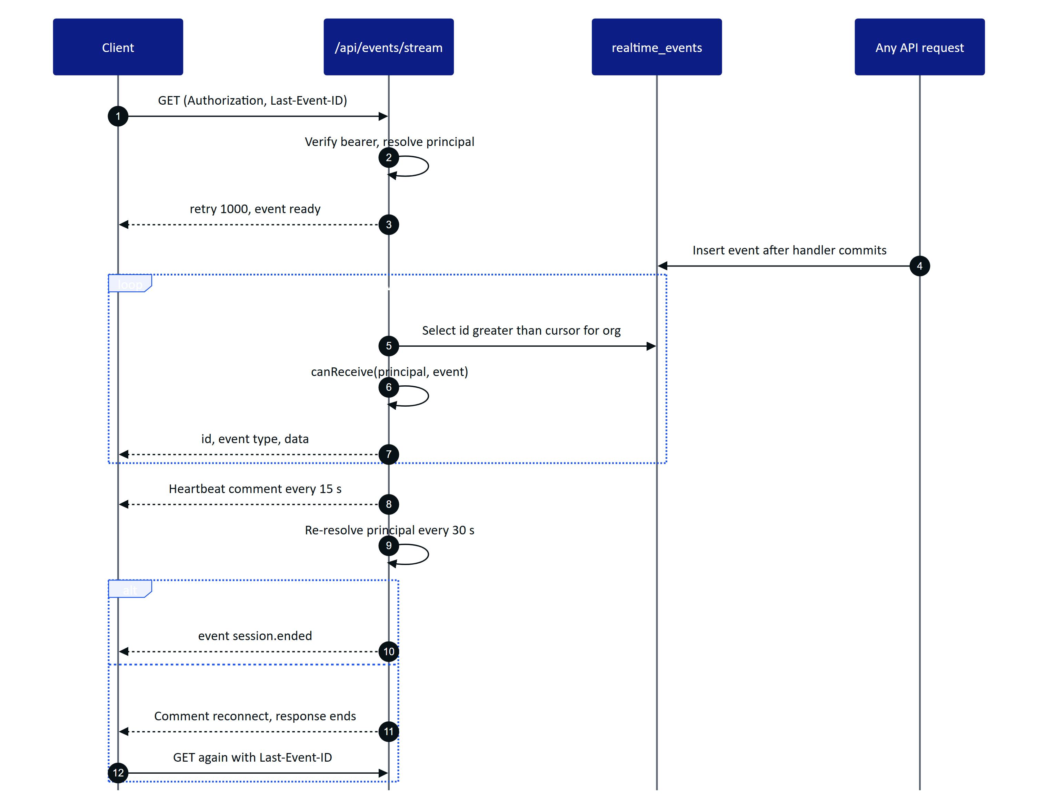
Figure 10. SSE stream lifecycle in db mode: authorize per event, heartbeat, revalidate, reconnect before the function limit

8.3 Per-connection authorization
Every event names its organization and optionally a site, a permission, a list of user ids or a list of device ids. canReceive() in apps/api/src/modules/realtime.ts delivers an event to a connection only when all of these hold:
- the event's organization is the principal's organization;
- if the event names devices, the connection is one of those devices (device-targeted events go to nobody else);
- if the event names users, the principal is one of them;
- if the event names a site, the site is in the principal's scope;
- if the event names a permission, the principal holds it (with the device cap applied for glasses).
The stream re-resolves the principal every 30 seconds and sends session.ended when the user or device session is no longer valid, so a revoked device stops receiving data within half a minute even if its stream stays open.

8.4 Event catalogue
Table 12. SSE event types, their audience and payload
Event | Published by | Audience filter | Payload
ready | Stream start | The connection | kind (user or device), serverTime
session.ended | Stream revalidation | The connection | {}
alarm.created | Alarm engine on breach or stale data | Site, alarm.read | Full alarm event row
alarm.updated | Transitions, assignment, condition cleared, peak update | Site, alarm.read | Full row, or { id, clearedAt } when the condition clears
telemetry.reading | Ingestion (newest reading only) | Site, telemetry.read | sensorId, assetId, tag, value, unit, ts, quality, source, synthetic
telemetry.corrected | Reading correction | Site, telemetry.read | sensorId, readingId, action
sensor.updated | Sensor edit | Site, telemetry.read | id
asset.updated | Asset edit, simulator offline event | Site, asset.read | id, status
inspection.updated | Create, edit, responses, transitions | Site, inspection.read | id, status, assignedTo or progressChanged
maintenance.updated | Create, edit, checklist, transitions, inspection follow-up | Site, maintenance.read | id, status
auditdoc.updated | Capture, enhance, review, verify, approve, rename | Site, auditdoc.read | id, status, title
notification.created | Any personal notification | That user | Full notification row
device.paired | Pairing completion | Site, device.read | id, name
device.updated | Assign, suspend, reactivate, revoke | Site, device.read | id, optionally status
device.context_changed | Reassign, site change, suspend, reactivate, operator deactivated | That device | reason
device.revoked | Device revoke | That device | reason: "revoke"
device.profile_changed | UI profile publish, rollback, assignment change | Affected devices | profileId, version or reason
ui_profile.updated | Same as above | device.read | profileId, reason, affectedDevices
pairing.completed | Pairing completion | The approving user | challengeId, deviceId
simulation.step | Demo simulator | Site, telemetry.read | runId, scenario, step, events

Glasses react to device.context_changed, device.revoked and device.profile_changed by refetching GET /api/device/context or returning to the pairing screen. The console invalidates its query cache by event type.
NOTE
A code comment in the Android client names an alarm.raised event. The server publishes alarm.created; there is no alarm.raised event.

9 Health
app.ts registers one route outside the modules.

GET /api/health
Liveness probe. Does not touch the database.
- Auth: public. Permission: none.
- Response: 200 { "ok": true, "time": "2026-10-22T08:14:03.512Z" }.

10 Authentication module
File: apps/api/src/modules/auth.ts. All routes run in system context (withSystem) because they act on users and sessions, which are not tenant-partitioned. The refresh and demo cookies are scoped to the path /api/auth, so they are sent only to this module.
Table 13. Authentication endpoints
Method | Path | Auth | Limit | Purpose
POST | /api/auth/demo | public (demo mode) | 20/min | One-click sign-in as a named guest
POST | /api/auth/login | public | 10/min | Email and password sign-in
POST | /api/auth/mfa/verify | MFA token | 10/min | Complete sign-in with a TOTP code
POST | /api/auth/refresh | cookie | 60/min | Rotate the refresh cookie, new access token
POST | /api/auth/logout | cookie | global | End the session family
GET | /api/auth/me | user or platform admin | global | Current session view
POST | /api/auth/switch-org | user | global | Start a session in another organization
POST | /api/auth/change-password | user | global | Change password, end other sessions
POST | /api/auth/password-reset/request | public | 5/min | Email a reset link
POST | /api/auth/password-reset/complete | public | 10/min | Set a new password from a reset link
GET | /api/auth/invitations/:token | public | 30/min | Preview an invitation
POST | /api/auth/invitations/accept | public | 10/min | Accept an invitation, create or join account
POST | /api/auth/mfa/setup | user | global | Generate a TOTP secret
POST | /api/auth/mfa/enable | user | global | Turn MFA on
POST | /api/auth/mfa/disable | user | global | Turn MFA off
GET | /api/auth/sessions | user | global | List active sessions
DELETE | /api/auth/sessions/:id | user | global | Revoke one session

POST /api/auth/demo
Creates (or reuses) a named guest account in the demo tenant and signs it in. Available only when the server runs in demo mode; otherwise the route answers 404 not_found as if it did not exist.
- Auth: public. Limit: 20 per minute.
- Request: name, 2 to 40 characters after trimming. Whitespace is collapsed and the name is NFKC-normalized.
- Response: 200 session view (see the authentication chapter) plus Set-Cookie: hg_refresh and hg_demo.
- Errors: 404 not_found (demo mode off), 400 validation_failed ("Enter your name").
- Side effects: audit auth.login with metadata.demoGuest: true; the guest receives copies of the demo owner's scheduled inspections and open maintenance tasks.
curl -s -c cookies.txt -X POST https://hydrisview.vercel.app/api/auth/demo \
-H "content-type: application/json" \
-d '{"name":"Priya Raman"}' | jq -r .accessToken

POST /api/auth/login
Signs in with email and password. Returns either a session or an MFA challenge.
- Auth: public. Limit: 10 per minute.
- Request: email (trimmed, lower-cased, valid email), password (1 to 200 characters).
- Response: 200 session view with Set-Cookie: hg_refresh, or 200 { "mfaRequired": true, "mfaToken": "..." }.
- Errors: 401 invalid_credentials (unknown email, wrong password, inactive account), 423 account_locked.
- Side effects: audit auth.login or auth.login_failed; failure counter and lockout (5 failures, 15 minutes).
{ "email": "tarun@hydris.ai", "password": "correct horse battery staple" }

POST /api/auth/mfa/verify
Completes a sign-in that returned mfaRequired.
- Auth: the mfaToken from login, in the body. Limit: 10 per minute.
- Request: { "mfaToken": "...", "code": "123456" }.
- Response: 200 session view with Set-Cookie: hg_refresh.
- Errors: 401 mfa_expired (token older than 5 minutes or invalid), 401 unauthenticated (wrong token type), 401 invalid_mfa_code.
- Side effects: audit auth.login with metadata.mfa: true.

POST /api/auth/refresh
Rotates the refresh session and issues a new access token. Send it with credentials (cookies) included and no body.
- Auth: hg_refresh cookie (demo mode also accepts hg_demo). Limit: 60 per minute.
- Response: 200 session view with a new access token and new cookies.
- Errors: 401 no_session, 401 session_expired, 401 session_revoked. Every 401 clears the cookies.
- Side effects: on replay outside the 30-second grace window, revokes the family and writes auth.refresh_reuse_detected.

POST /api/auth/logout
Revokes the session family of the presented refresh cookie and clears the cookies. Always succeeds.
- Auth: hg_refresh cookie (optional). Response: 200 { "ok": true }.
- Side effects: audit auth.logout when a session was found.

GET /api/auth/me
Returns the session view for the bearer token. Unlike other user routes it also answers for platform administrators who have no organization membership (with org: null, role: null and empty permissions).
- Auth: user access token. Response: 200 session view without accessToken.
- Errors: 401 unauthenticated.

POST /api/auth/switch-org
Moves the caller to another organization they belong to. The current session family is revoked and a new one is started; the target becomes the user's default organization.
- Auth: user. Request: { "orgId": "<uuid>" }.
- Response: 200 session view for the new organization, new cookie.
- Errors: 403 forbidden ("Not a member of that organization").

POST /api/auth/change-password
- Auth: user. Request: { "currentPassword": "...", "newPassword": "..." }. The new password must be 12 to 200 characters and not one repeated character.
- Response: 200 session view. Every other session of the user is revoked; this call starts a fresh one.
- Errors: 400 weak_password, 400 wrong_password.
- Side effects: audit auth.password_changed.

POST /api/auth/password-reset/request
Sends a reset link valid for 30 minutes. The response is identical whether or not the account exists.
- Auth: public. Limit: 5 per minute. Request: { "email": "..." }.
- Response: 200 { "ok": true }.
- Side effects: a message in mail_outbox (the development mail transport), audit auth.password_reset_requested for existing active accounts.

POST /api/auth/password-reset/complete
- Auth: public. Limit: 10 per minute. Request: { "token": "...", "password": "..." } (token at least 10 characters).
- Response: 200 { "ok": true }. Clears the lockout, marks the email verified and revokes every session.
- Errors: 400 weak_password, 400 invalid_token.
- Side effects: audit auth.password_reset.

GET /api/auth/invitations/:token
Previews an invitation before the person accepts it.
- Auth: public. Limit: 30 per minute.
- Response: 200 { "email", "name", "role", "orgName", "existingAccount" }. existingAccount tells the page to ask for the existing password instead of a new one.
- Errors: 400 invalid_invitation.

POST /api/auth/invitations/accept
Accepts an invitation. Accepting doubles as email verification. If an account with the invited email exists, its password is required; otherwise a new account is created with the given password.
- Auth: public. Limit: 10 per minute.
- Request: { "token": "...", "name": "Priya Raman", "password": "..." } (name optional, 2 to 120 characters).
- Response: 200 session view in the inviting organization.
- Errors: 400 invalid_invitation, 400 wrong_password, 400 weak_password.
- Side effects: membership created or reactivated with the invited role and site scope; audit member.invitation_accepted.

POST /api/auth/mfa/setup
- Auth: user. Response: 200 { "secret": "JBSWY3DPEHPK3PXP...", "otpauthUrl": "otpauth://totp/Hydris:..." }.
- Errors: 400 mfa_already_enabled.
- Notes: the secret is stored encrypted but MFA is not on until mfa/enable succeeds.

POST /api/auth/mfa/enable
- Auth: user. Request: { "code": "123456" }. Response: 200 { "ok": true }.
- Errors: 400 invalid_mfa_code. Side effects: audit auth.mfa_enabled.

POST /api/auth/mfa/disable
- Auth: user. Request: { "password": "...", "code": "123456" }. Response: 200 { "ok": true }.
- Errors: 400 wrong_password, 400 invalid_mfa_code. Side effects: secret deleted, audit auth.mfa_disabled.

GET /api/auth/sessions
Lists the caller's live sessions (not revoked, not rotated, not expired), newest first.
- Auth: user.
- Response: 200 { "sessions": [{ "id", "userAgent", "ip", "createdAt", "current" }] }. id is the session family id; current marks the caller's own session.

DELETE /api/auth/sessions/:id
Revokes one session family of the caller (for example "sign out my tablet").
- Auth: user. Response: 200 { "ok": true }. Side effects: audit auth.session_revoked.

11 Organization module
File: apps/api/src/modules/org.ts. Covers platform administration, organization settings, members and invitations, personal notifications and the audit log.
Table 14. Organization endpoints
Method | Path | Auth | Permission | Purpose
GET | /api/platform/organizations | platform | platform admin | List all tenants
POST | /api/platform/organizations | platform | platform admin | Create a tenant and invite its first admin
POST | /api/platform/organizations/:id/status | platform | platform admin | Suspend or reactivate a tenant
GET | /api/org | any | none | Current organization
PATCH | /api/org | user | org.manage | Rename, region, timezone
GET | /api/members | user | member.read | Members, pending invitations, assignable roles
GET | /api/members/:userId | user | member.read | Member detail with devices and work
POST | /api/invitations | user | member.manage | Invite a person
DELETE | /api/invitations/:id | user | member.manage | Revoke an invitation
PATCH | /api/members/:userId | user | member.manage | Role, title, site scope, status
GET | /api/notifications | any | none | Own notifications
POST | /api/notifications/read | any | none | Mark own notifications read
GET | /api/audit | user | audit.read | Organization audit log

11.1 Platform administration

GET /api/platform/organizations
- Auth: user token of a platform administrator (membership not required). Errors: 401 unauthenticated.
- Response: 200 { "organizations": [{ "id", "name", "slug", "isDemo", "status", "region", "createdAt", "members", "sites" }] }.

POST /api/platform/organizations
Creates an organization and an invitation for its first organization administrator.
- Auth: platform administrator.
- Request:
{
"name": "Coimbatore Municipal STP",
"slug": "cbe-stp",
"region": "Tamil Nadu",
"timezone": "Asia/Kolkata",
"isDemo": false,
"admin": { "name": "Anand Kumar", "email": "anand@example.org" }
}
- Response: 201 { "organization": { ... }, "adminInvitationLink": "https://.../invite/<token>" }.
- Errors: 409 slug_taken, 400 validation_failed (slug must match ^[a-z0-9-]{2,40}$).
- Side effects: invitation email to mail_outbox, audit organization.created.

POST /api/platform/organizations/:id/status
- Auth: platform administrator. Request: { "status": "active" | "suspended" }.
- Response: 200 { "organization": { ... } }. Errors: 404 not_found.
- Notes: a suspended organization fails principal resolution for every member and device, and its gateway keys stop working. Audit organization.suspended or organization.reactivated.

11.2 Organization settings

GET /api/org
- Auth: any. Response: 200 { "organization": { "id", "name", "slug", "isDemo", "status", "region", "timezone", ... } }.

PATCH /api/org
- Auth: user. Permission: org.manage.
- Request: any of name (2 to 120), region (up to 80, nullable), timezone (up to 60).
- Response: 200 { "organization": { ... } }. Side effects: audit organization.updated.

11.3 Members and invitations

GET /api/members
- Auth: user. Permission: member.read.
- Response: 200 { "members": [...], "invitations": [...], "assignableRoles": [...] }. Each member carries membershipId, userId, name, email, role, status, allSites, siteIds, title, lastLoginAt, mfaEnabled, devices (active assigned glasses), openInspections and openTasks. Pending invitations are included only for organization administrators and factory managers.

GET /api/members/:userId
- Auth: user. Permission: member.read.
- Response: 200 { "member", "devices", "inspections", "tasks", "sessions" } with the ten most recent inspections and tasks. sessions (live session families) is filled only for organization administrators.
- Errors: 404 not_found.

POST /api/invitations
Invites a person by email. The link is also returned so administrators can share it when mail delivery is not configured.
- Auth: user. Permission: member.manage.
- Request:
{ "email": "karthik@example.org", "name": "Karthik S", "role": "field_operator", "allSites": false, "siteIds": ["2d4c..."] }
- Response: 201 { "invitationLink": "https://.../invite/<token>" }.
- Errors: 403 forbidden (role not assignable by the caller, or sites outside the caller's scope), 400 sites_required, 400 invalid_sites, 409 already_member.
- Notes: any open invitation for the same email is revoked first. Invitations expire after 7 days. Audit member.invited.

DELETE /api/invitations/:id
- Auth: user. Permission: member.manage. Response: 200 { "ok": true }.
- Errors: 404 not_found (unknown or already accepted). Side effects: audit member.invitation_revoked.

PATCH /api/members/:userId
Changes a member's role, title, site scope or status.
- Auth: user. Permission: member.manage.
- Request: any of role, title (up to 80, nullable), allSites, siteIds (replaces the list), status (active or deactivated).
- Response: 200 { "ok": true }.
- Errors: 403 forbidden (changing your own role or status, managing a role you cannot assign, granting sites outside your scope), 404 not_found.
- Side effects: deactivation takes effect at once: the member's sessions in this organization are revoked, their glasses are unassigned and each device's session version is bumped, with device.context_changed (reason operator_deactivated) sent to each device. Audit member.deactivated or member.updated.

11.4 Notifications

GET /api/notifications
Returns the caller's 50 most recent notifications and the unread count. Glasses need the notifications screen enabled in their UI profile.
- Auth: any. Response: 200 { "notifications": [{ "id", "kind", "title", "body", "link", "severity", "entityType", "entityId", "readAt", "createdAt" }], "unread": 3 }.

POST /api/notifications/read
Marks notifications read. Without ids, marks all of the caller's unread notifications.
- Auth: any. Request: { "ids": ["<uuid>", ...] } (optional, up to 200). Response: 200 { "ok": true }.
- Notes: glasses need the notifications screen and the mark_notifications_read action.

11.5 Audit log

GET /api/audit
Searches the append-only audit trail of the organization, newest first.
- Auth: user. Permission: audit.read.
- Query: action (prefix match, for example alarm.), entityType, q (summary or actor name contains), from, to, limit (1 to 500, default 100), before (exclusive cursor: pass the at of the last row).
- Response: 200 { "events": [{ "id", "action", "entityType", "entityId", "summary", "metadata", "ip", "at", "actorUserId", "actorDeviceId", "actorName" }] }. actorName falls back to the actor label (alarm engine, simulator, glasses) for non-human actors.

12 Plant hierarchy and records module
File: apps/api/src/modules/plant.ts. The plant is modelled as site, facility, process area, asset and sensor. This module also owns edge gateway credentials, documents (SOPs, manuals, datasheets), file attachments, per-record change history and the navigator tree. Codes and tags (site code, facility code, process area code, asset tag, sensor tag) are 1 to 24 characters from [A-Za-z0-9._-]. Delete is offered only for assets without history; everything else is archived with an archived flag so operational history stays intact.
Table 15. Plant endpoints
Method | Path | Auth | Permission | Purpose
GET | /api/sites | any | scope only | Sites with counts
POST | /api/sites | user | site.manage (organization-wide) | Create a site
GET | /api/sites/:id | any | scope only | Site with facilities, areas, assets, gateways
PATCH | /api/sites/:id | user | site.manage | Edit a site
POST | /api/sites/:id/archive | user | site.manage | Archive or restore
POST | /api/facilities | user | site.manage | Create a facility
PATCH | /api/facilities/:id | user | site.manage | Edit, archive or restore
POST | /api/process-areas | user | site.manage | Create a process area
PATCH | /api/process-areas/:id | user | site.manage | Edit, archive or restore
GET | /api/assets | any | scope only | Filtered asset list with health
POST | /api/assets | user | asset.manage | Create an asset
GET | /api/assets/:id | any | scope only | Asset detail with sensors, alarms, work, documents, files
PATCH | /api/assets/:id | any | asset.manage, or inspection.execute for status and notes only | Edit, archive or restore
DELETE | /api/assets/:id | user | asset.manage | Delete an asset without history
GET | /api/sensors | any | scope only | Sensors with freshness
POST | /api/sensors | user | sensor.manage | Create a sensor
GET | /api/sensors/:id | any | telemetry.read | Sensor detail, including archived
PATCH | /api/sensors/:id | user | sensor.manage | Edit, bind gateway, archive or restore
POST | /api/gateways | user | gateway.manage | Create an edge gateway, returns its key once
POST | /api/gateways/:id/revoke | user | gateway.manage | Revoke a gateway key
GET | /api/documents | any | document.read | Search documents
GET | /api/documents/:id | any | document.read | One document
POST | /api/documents | user | document.manage | Create a document
PATCH | /api/documents/:id | user | document.manage | Edit, approve, archive
POST | /api/attachments | any | depends on owner type | Upload a file
GET | /api/attachments/:id | any | tenant | Download a file
GET | /api/history/:entityType/:entityId | any | depends on entity type | Change history of one record
GET | /api/hierarchy | any | scope only | Site to sensor navigator tree

12.1 Sites

GET /api/sites
- Auth: any. Permission: site scope only.
- Query: archived ("true" includes archived sites; default "false").
- Response: 200 { "sites": [{ ...site, "facilities": 2, "assets": 31, "openAlarms": 4, "criticalAlarms": 1 }] }. Site fields include id, name, code, address, city, country, lat, lng, timezone, layoutWidthM, layoutHeightM, archivedAt.

POST /api/sites
- Auth: user. Permission: site.manage, and the caller must be organization-wide.
- Request:
{ "name": "Ukkadam STP", "code": "UKD", "city": "Coimbatore", "country": "India", "lat": 10.99, "lng": 76.96, "timezone": "Asia/Kolkata", "layoutWidthM": 240, "layoutHeightM": 160 }
- Response: 201 { "site": { ... } }.
- Errors: 400 forbidden_scope, 409 code_taken. Side effects: audit site.created.
- Notes: layoutWidthM and layoutHeightM (10 to 5000 metres) size the plant map shown on the glasses.

GET /api/sites/:id
- Auth: any. Permission: site scope.
- Response: 200 { "site", "facilities", "processAreas", "assets", "gateways" }. Assets carry the same health summary as GET /api/assets. Gateways show keyPrefix but never the key.
- Errors: 404 not_found.

PATCH /api/sites/:id
- Auth: user. Permission: site.manage and site scope. Request: any site field.
- Response: 200 { "site": { ... } }. Side effects: audit site.updated.

POST /api/sites/:id/archive
- Auth: user. Permission: site.manage. Request: { "archived": true } or false to restore.
- Response: 200 { "site": { ... } }. Side effects: audit site.archived or site.restored.

12.2 Facilities and process areas

POST /api/facilities
- Auth: user. Permission: site.manage and scope over siteId.
- Request: siteId, name, code, kind (etp, stp, wtp, cetp, other), optional capacityM3PerDay and description.
- Response: 201 { "facility": { ... } }. Errors: 404 not_found (site), 409 code_taken.
- Side effects: audit facility.created.

PATCH /api/facilities/:id
- Auth: user. Permission: site.manage. Request: any facility field except siteId, plus archived.
- Response: 200 { "facility": { ... } }. Side effects: audit facility.updated.

POST /api/process-areas
- Auth: user. Permission: site.manage.
- Request: facilityId, name, code, kind (intake, screening, equalization, primary_treatment, aeration, clarification, filtration, disinfection, sludge_handling, chemical_dosing, discharge, utilities, other), optional sortOrder and polygon (3 to 64 [x, y] points in metres on the site layout).
- Response: 201 { "processArea": { ... } }. The site is taken from the facility.
- Errors: 404 not_found, 409 code_taken. Side effects: audit process_area.created.

PATCH /api/process-areas/:id
- Auth: user. Permission: site.manage. Request: any field except facilityId, plus archived.
- Response: 200 { "processArea": { ... } }. Side effects: audit process_area.updated.

12.3 Assets

GET /api/assets
- Auth: any. Permission: site scope.
- Query: siteId, facilityId, processAreaId, type, status, q (tag, name or manufacturer contains), archived.
- Response: 200 { "assets": [...] }, ordered by tag. Each asset adds areaName, facilityName, siteName, openAlarms, worstSeverity, sensorCount and openTasks to its row.
{
"assets": [
{
"id": "a91f...", "tag": "P-101", "name": "Raw sewage lift pump 1", "type": "pump", "status": "operational",
"criticality": "high", "siteName": "Ukkadam STP", "facilityName": "STP 1", "areaName": "Intake",
"openAlarms": 1, "worstSeverity": "high", "sensorCount": 3, "openTasks": 0
}
]
}

POST /api/assets
- Auth: user. Permission: asset.manage.
- Request: facilityId, tag, name, type (pump, blower, tank, valve, mixer, clarifier, filter, dosing_pump, analyzer, motor, screen, diffuser, uv_unit, other), optional processAreaId, manufacturer, model, serialNumber, installedOn, criticality (low, medium, high), status, specs (string to string or number map), notes, positionX, positionY (metres on the site layout).
- Response: 201 { "asset": { ... } }.
- Errors: 404 not_found (facility), 400 invalid_process_area, 409 tag_taken.
- Side effects: audit asset.created.

GET /api/assets/:id
- Auth: any. Permission: site scope.
- Response: 200 { "asset", "sensors", "alarms", "maintenance", "inspections", "documents", "attachments" }. Sensors carry freshness (live, delayed, stale, no_data). Alarms, tasks and inspections are the 20 most recent. Documents are approved ones linked to the asset or to its asset type.
- Errors: 404 not_found.

PATCH /api/assets/:id
- Auth: any. Permission: asset.manage; a body containing only status and notes needs only inspection.execute, so operators can record an asset as degraded from the field.
- Request: any asset field except facilityId, plus archived.
- Response: 200 { "asset": { ... } }.
- Errors: 400 validation_failed (process area in another facility), 409 tag_taken.
- Side effects: audit asset.updated, asset.archived or asset.restored with field-level changes; SSE asset.updated.

DELETE /api/assets/:id
- Auth: user. Permission: asset.manage. Response: 200 { "ok": true }.
- Errors: 409 in_use when sensors, alarms, inspections or maintenance tasks reference the asset.
- Side effects: audit asset.deleted.

12.4 Sensors

GET /api/sensors
- Auth: any. Permission: site scope. Glasses need the measurements or assets screen.
- Query: siteId, assetId, measurand, q, archived ("false" default, "true" all, "only" archived).
- Response: 200 { "sensors": [...] }. Each sensor adds assetTag, assetName, openAlarms, rules (enabled rule count) and freshness; the row carries lastValue, lastTs, lastQuality, lastSource, unit, method and expectedIntervalS.

POST /api/sensors
- Auth: user. Permission: sensor.manage.
- Request: assetId, tag, name, measurand (16 values: ph, temperature, dissolved_oxygen, turbidity, conductivity, flow_rate, tank_level, pressure, motor_current, vibration, runtime_hours, tss, cod, bod, ammonia, residual_chlorine), optional method (continuous, lab, manual), expectedIntervalS (1 s to 30 days), gatewayId, sourceRef, enabled.
- Response: 201 { "sensor": { ... } }. The unit comes from the measurand definition; method and interval default to the measurand's (60 seconds for continuous, one day otherwise).
- Errors: 404 not_found (asset), 409 tag_taken. Side effects: audit sensor.created.

GET /api/sensors/:id
Returns one sensor, including archived ones, with what the edit form needs.
- Auth: any. Permission: telemetry.read and site scope.
- Response: 200 { "sensor", "asset", "gateway", "gateways", "counts" }. sensor adds freshness, label and decimals; gateways lists the site's active gateways; counts gives rules, readings and corrections.

PATCH /api/sensors/:id
- Auth: user. Permission: sensor.manage. Request: any field except assetId and measurand, plus archived.
- Response: 200 { "sensor": { ... } }.
- Errors: 400 validation_failed (gateway on another site or revoked), 409 source_ref_taken, 409 tag_taken.
- Side effects: audit sensor.updated, sensor.archived or sensor.restored; SSE sensor.updated.
- Notes: sourceRef is the identifier a gateway sends instead of the tag (for example a PLC register name); it must be unique on the site against both tags and other source references.

12.5 Gateways

POST /api/gateways
Creates an edge gateway credential for one site.
- Auth: user. Permission: gateway.manage and site scope.
- Request: { "siteId": "<uuid>", "name": "STP-1 edge box", "protocol": "https" }. protocol is https (default), mqtt or opcua; only HTTPS ingestion exists today (see the planned API chapter).
- Response:
{ "gateway": { "id": "e3b7...", "name": "STP-1 edge box", "keyPrefix": "hgw_Zk3pQ" }, "apiKey": "hgw_Zk3pQ...full key..." }
- Side effects: audit gateway.created.
IMPORTANT
apiKey is returned exactly once. Only its SHA-256 hash and a 10-character prefix are stored. A lost key cannot be recovered: revoke the gateway and create a new one.

POST /api/gateways/:id/revoke
- Auth: user. Permission: gateway.manage. Response: 200 { "ok": true }.
- Side effects: the key stops working on the next request; audit gateway.revoked.

12.6 Documents
Documents are SOPs, manuals, datasheets, safety notes and troubleshooting guides. They are versioned: editing the body of an approved document increments version and returns it to draft until approved again. Field operators, viewers and glasses see approved documents only.

GET /api/documents
- Auth: any. Permission: document.read. Glasses need the sops screen and view_sops action.
- Query: q (title contains or full-text match on the body), kind, assetId, status (draft, approved, archived).
- Response: 200 { "documents": [{ "id", "title", "kind", "status", "version", "assetId", "assetType", "siteId", "tags", "updatedAt", "approvedAt" }] }. Organization-wide documents (no site) are visible to every site.

GET /api/documents/:id
- Auth: any. Permission: document.read. Glasses need view_sops.
- Response: 200 { "document": { ..., "body": "markdown" } }.
- Errors: 404 not_found (missing, out of scope, or not approved for operators, viewers and devices).

POST /api/documents
- Auth: user. Permission: document.manage.
- Request: title (3 to 160), kind, body (up to 100,000 characters), optional siteId, assetId, assetType, tags (up to 20).
- Response: 201 { "document": { ... } } in draft. Side effects: audit document.created.

PATCH /api/documents/:id
- Auth: user. Permission: document.manage.
- Request: any document field plus status. Setting status: "approved" records the caller as approver.
- Response: 200 { "document": { ... } }.
- Errors: 404 not_found, 400 forbidden_scope (making a document organization-wide without organization-wide scope), 400 validation_failed (asset on another site).
- Side effects: audit document.approved, document.archived, document.restored or document.updated with field changes, contentChanged and the new version.

12.7 Attachments

POST /api/attachments
Uploads one evidence file and links it to an inspection, maintenance task, asset or alarm.
- Auth: any. Content type: multipart/form-data with fields ownerType (inspection, maintenance, asset, alarm), ownerId and one file (at most 10 MB).
- Permission: by owner type: inspection.execute, maintenance.request, asset.manage or alarm.acknowledge; the owner record must be in scope.
- Response: 201 { "attachment": { "id", "ownerType", "ownerId", "filename", "mime", "sizeBytes", "sha256", "uploadedBy", "deviceId", "createdAt" } }.
- Errors: 400 file_required, 400 unsupported_type, 400 content_mismatch, 404 not_found.
- Notes: allowed types are JPEG, PNG, WebP, PDF and plain text, verified against the file's magic bytes. Files are stored under a random key on disk or in a private Vercel Blob store and are never exposed as public URLs. Audit attachment.uploaded.
curl -X POST https://hydrisview.vercel.app/api/attachments \
-H "authorization: Bearer $TOKEN" \
-F ownerType=maintenance -F ownerId=4be1... -F file=@seal-leak.jpg

GET /api/attachments/:id
Streams a stored file with its MIME type, content-disposition: inline and x-content-type-options: nosniff.
- Auth: any. Errors: 404 not_found.
- Notes: the lookup runs under the tenant's RLS. The handler does not re-check the site scope of the owning record, so any authenticated member of the organization who knows an attachment id can download it. Clients use the authenticated blob helper so the token never appears in a URL.

12.8 History and hierarchy

GET /api/history/:entityType/:entityId
Returns the audit events of one record, newest first, for the "History" panels in the console.
- Auth: any. Path: entityType is one of asset, sensor, alarm_rule, maintenance, document, inspection_template.
- Permission: asset.read, telemetry.read, alarm.read, maintenance.read, document.read or inspection.read respectively; the record must be in scope. Non-approved documents need document.manage.
- Query: limit (1 to 500, default 100).
- Response: 200 { "events": [{ "id", "action", "summary", "metadata", "at", "actor": { "id", "name" } }] }. Actors are users, devices (named "Device" or their label) or the system.

GET /api/hierarchy
Returns the full navigator tree for the caller's active sites in one call: sites, facilities, process areas, assets (with openAlarms and worstSeverity), each asset's sensors (with lastValue, lastTs and freshness), and per facility the unassignedAssets that have no process area.
- Auth: any. Permission: site scope.
- Response: 200 { "sites": [{ "id", "name", "code", "facilities": [{ ..., "processAreas": [{ ..., "assets": [...] }], "unassignedAssets": [...] }] }] }.

13 Telemetry module
File: apps/api/src/modules/telemetry.ts. Every reading, whatever its source, goes through one function, ingest(): validation, unit normalization, idempotent storage, out-of-order handling, alarm evaluation and realtime fan-out. The sources are edge gateways (gateway), people entering values in the console (manual and lab) and the demo simulator (simulator). Stored readings are never modified; corrections are appended in a separate table and the effective value of a reading is its most recent correction.
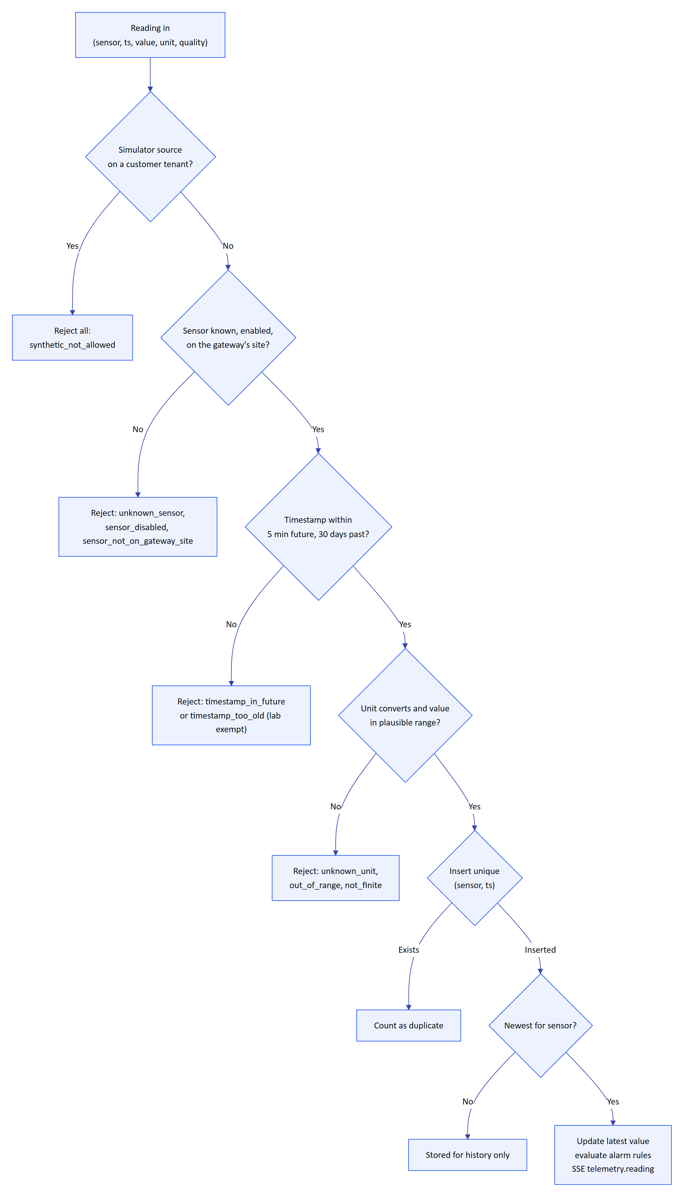
Figure 11. The single ingestion pipeline shared by gateways, manual and lab entry, and the demo simulator
Readings are processed in timestamp order within a batch. A reading older than the sensor's latest is stored for history and exports but does not overwrite the latest value or re-trigger alarms. Readings with quality bad update the latest value but are not evaluated against alarm rules.
Table 16. Telemetry endpoints
Method | Path | Auth | Permission | Purpose
POST | /api/ingest/v1/readings | gateway | gateway key | Batch ingestion from an edge gateway
POST | /api/telemetry/manual | user or device | inspection.execute (manual) or sensor.manage (lab) | Record one reading by hand
GET | /api/telemetry/sensors/:id/history | any | telemetry.read | Downsampled chart series
GET | /api/telemetry/sensors/:id/export.csv | any | report.export | Raw readings as CSV
GET | /api/telemetry/sensors/:id/readings | any | telemetry.read | Paged raw readings with provenance
POST | /api/telemetry/readings/:readingId/corrections | user | sensor.manage | Correct or invalidate a reading

POST /api/ingest/v1/readings
Accepts a batch of up to 500 readings from an edge gateway. The gateway identifies sensors by tag or by sourceRef, and only sensors on the gateway's own site are accepted.
- Auth: Authorization: Bearer hgw_.... The key must be active and its organization active.
- Limit: 1200 requests per minute per IP.
- Request:
{
"readings": [
{ "sensor": "PT-101-VIB", "ts": "2026-10-22T13:44:00+05:30", "value": 7.4, "unit": "mm/s", "quality": "good", "messageId": "plc1-000918" },
{ "sensor": "40001", "ts": "2026-10-22T13:44:00+05:30", "value": 6.92 }
]
}
- Response: 200. rejected[].index refers to the position in the request array.
{ "accepted": 1, "duplicates": 0, "alarmsRaised": 1, "rejected": [{ "index": 1, "reason": "unknown_sensor" }] }
- Errors: 401 invalid_gateway_key, 400 validation_failed (ts must be ISO 8601 with offset, 1 to 500 readings).
- Side effects: gateway lastSeenAt updated; sensor latest values; alarm events and notifications; SSE telemetry.reading and alarm.created.
- Notes: a partially bad batch still returns 200; inspect rejected. Rejection reasons are unknown_sensor, sensor_disabled, sensor_not_on_gateway_site, timestamp_in_future, timestamp_too_old, unknown_unit, out_of_range and not_finite. messageId is stored for traceability; deduplication is by sensor and timestamp.

POST /api/telemetry/manual
Records one reading entered by a person, for example a lab COD result or a hand-held pH reading.
- Auth: user or device. Permission: inspection.execute for source: "manual", sensor.manage for source: "lab"; the sensor must be in scope.
- Request: { "sensorId": "<uuid>", "value": 182, "unit": "mg/L", "ts": "2026-10-22T09:00:00+05:30", "source": "lab" } (ts defaults to now, source to manual).
- Response: 201 { "accepted": 1, "duplicates": 0, "alarmsRaised": 0, "rejected": [], "readingId": 99812, "recordedBy": { "id": "..." } }.
- Errors: 400 method_mismatch, 400 reading_rejected (with details.reason), 409 duplicate_reading.
- Side effects: audit telemetry.manual_entry (the provenance record of who entered the value).

GET /api/telemetry/sensors/:id/history
Returns a chart-ready series. When the range holds more readings than points, the server averages them into equal time buckets and returns min, max and count per bucket; otherwise it returns the raw readings. Invalidated readings are excluded and corrected readings use their corrected value.
- Auth: any. Permission: telemetry.read. Glasses need the measurements or assets screen.
- Query: from (default to minus 24 hours), to (default now), points (10 to 2000, default 240).
- Response:
{
"sensor": { "id": "c0d1...", "tag": "PT-101-VIB", "unit": "mm/s", "freshness": "live", "label": "Vibration", "decimals": 1, "typicalRange": [0, 4.5] },
"from": "2026-10-21T08:00:00.000Z", "to": "2026-10-22T08:00:00.000Z",
"bucketSeconds": 360, "totalReadings": 1440,
"points": [{ "t": "2026-10-21T08:00:00.000Z", "v": 3.12, "min": 2.9, "max": 3.4, "n": 6 }],
"corrections": { "corrected": 1, "invalidated": 2 }
}
- Errors: 400 invalid_range, 404 not_found. bucketSeconds is null when raw readings are returned.

GET /api/telemetry/sensors/:id/export.csv
Exports raw readings with original and effective values and the latest correction of each.
- Auth: any. Permission: report.export.
- Query: from and to (both required, at most 93 days apart).
- Response: 200 text/csv, file name sensor-<id>.csv, columns timestamp_utc, sensor_tag, original_value, effective_value, unit, quality, source, synthetic, status, correction_reason, corrected_by, corrected_at_utc. Cells that start with =, +, - or @ and are not numbers are prefixed with a quote to defuse spreadsheet formula injection.
- Errors: 400 range_too_large. Side effects: audit report.exported.

GET /api/telemetry/sensors/:id/readings
Pages through raw readings newest first, with who recorded manual values and the full correction trail.
- Auth: any. Permission: telemetry.read.
- Query: limit (1 to 200, default 50), offset, from, to, source (gateway, manual, lab, simulator), status (all, corrected, invalidated).
- Response: 200 { "sensor", "total", "limit", "offset", "readings": [...] }. Each reading has id (integer), ts, receivedAt, quality, source, synthetic, originalValue, effectiveValue (null when invalidated), status (original, corrected, invalidated), recordedBy and corrections[].

POST /api/telemetry/readings/:readingId/corrections
Appends a correction or invalidation to one stored reading. The original row is never changed.
- Auth: user. Permission: sensor.manage and scope over the sensor.
- Request: { "action": "correct", "correctedValue": 7.1, "unit": "pH", "reason": "Probe recalibrated after drift" } or { "action": "invalidate", "reason": "Sensor was out of the tank during cleaning" }. reason is 5 to 1000 characters; correctedValue is required for correct and forbidden for invalidate.
- Response: 201 { "correction": { ... }, "effectiveValue": 7.1 }.
- Errors: 404 not_found, 400 validation_failed (value implausible for the measurand), 409 no_change, 409 already_invalidated.
- Side effects: audit telemetry.reading_corrected or telemetry.reading_invalidated; the sensor's latest value is recomputed if this reading was the latest; SSE telemetry.corrected.

14 Alarms module
File: apps/api/src/modules/alarms.ts. Alarm rules are thresholds on one sensor: high_high, high, low, low_low with a deadband and an on-delay, or stale (no fresh data for five expected intervals). The engine raises one alarm event per breach and tracks two independent things: the measured condition (clearedAt is set when the value returns to normal) and the human lifecycle below. A cleared alarm stays open until people resolve it.
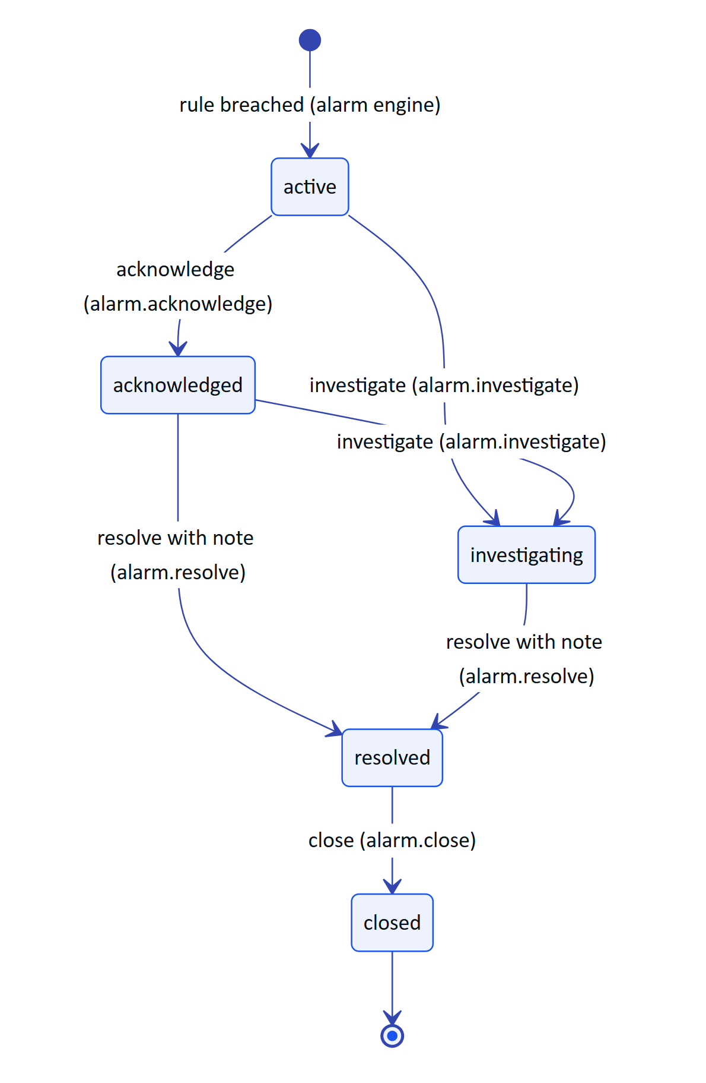
Figure 12. Alarm lifecycle (ALARM_TRANSITIONS in packages/domain/src/alarms.ts) with the permission each action needs
Critical and high alarms notify every active member with an operational role who has access to the site. Assignment notifies the assignee.
Table 17. Alarm endpoints
Method | Path | Auth | Permission | Purpose
GET | /api/alarms | any | alarm.read | Filtered alarm list, most urgent first
GET | /api/alarms/:id | any | alarm.read | Alarm with history, rule, procedure, follow-ups, allowed actions
POST | /api/alarms/:id/:action | any | per action | acknowledge, investigate, resolve, close
POST | /api/alarms/:id/assign | user | alarm.assign | Assign or unassign
POST | /api/alarms/:id/notes | any | alarm.acknowledge | Add a note to the history
GET | /api/alarm-rules | any | alarm.read | List rules
POST | /api/alarm-rules | user | alarm_rule.manage | Create a rule
PATCH | /api/alarm-rules/:id | user | alarm_rule.manage | Edit, enable or disable a rule
DELETE | /api/alarm-rules/:id | user | alarm_rule.manage | Delete, or disable if it has history

GET /api/alarms
- Auth: any. Permission: alarm.read. Glasses need the alerts screen.
- Query: state (one of the five states, or open for active, acknowledged and investigating), severity (critical, high, medium, low), siteId, assetId, assignedToMe, from, to (on triggeredAt), limit (1 to 500, default 200).
- Response: 200 { "alarms": [...] } ordered by state (active first), then severity, then newest. Each alarm adds assetTag, assetName, sensorTag and assigneeName.
curl -s "https://hydrisview.vercel.app/api/alarms?state=open&severity=critical" \
-H "authorization: Bearer $TOKEN" | jq '.alarms[] | {id, title, state, triggerValue, unit}'
{
"alarms": [
{
"id": "5f0c2a7e-...", "siteId": "2d4c...", "assetId": "a91f...", "sensorId": "c0d1...", "ruleId": "77aa...",
"severity": "critical", "condition": "high_high", "state": "active",
"title": "High-high Vibration · P-101", "description": "Vibration 9.8 mm/s is above the high-high limit 9 mm/s",
"recommendedAction": "Stop the pump and check the coupling", "triggerValue": 9.8, "threshold": 9, "unit": "mm/s",
"peakValue": 10.2, "triggeredAt": "2026-10-22T08:10:00.000Z", "clearedAt": null, "assignedTo": null,
"synthetic": false, "assetTag": "P-101", "assetName": "Raw sewage lift pump 1", "sensorTag": "PT-101-VIB", "assigneeName": null
}
]
}

GET /api/alarms/:id
- Auth: any. Permission: alarm.read and site scope. Glasses need the alerts screen.
- Response: 200 { "alarm", "history", "rule", "procedure", "followUps", "assignee", "allowedActions", "canAssign" }. history lists triggered, condition_cleared, transitions, assignments and notes with actor names (Hydris for the engine). procedure is the SOP linked to the rule. allowedActions lists the transitions valid from the current state that the caller holds the permission for, so clients render exactly the right buttons.
- Errors: 404 not_found.

POST /api/alarms/:id/:action
Moves an alarm through its lifecycle. action is acknowledge, investigate, resolve or close.
- Auth: any. Permission: alarm.acknowledge, alarm.investigate, alarm.resolve or alarm.close. Glasses need the alerts screen, and for acknowledge also the acknowledge_alarm action.
- Request: { "note": "..." } (optional, up to 2000; required for resolve).
- Response: 200 { "alarm": { ...updated row } }.
- Errors: 409 invalid_transition (with details.state), 400 note_required, 409 stale_state, 404 not_found.
- Side effects: acknowledge records acknowledgedBy and acknowledgedAt; investigate self-assigns if unassigned; resolve records the resolution note; history row; audit alarm.<action> with via: user | device; SSE alarm.updated.
curl -s -X POST https://hydrisview.vercel.app/api/alarms/5f0c2a7e-.../acknowledge \
-H "authorization: Bearer $TOKEN" -H "content-type: application/json" -d '{}'

POST /api/alarms/:id/assign
- Auth: user. Permission: alarm.assign.
- Request: { "userId": "<uuid>" | null, "note": "..." }.
- Response: 200 { "alarm": { ... } }.
- Errors: 409 invalid_transition (closed alarms), 400 invalid_assignee, 404 not_found.
- Side effects: history assigned, audit alarm.assigned, notification alarm_assigned, SSE alarm.updated.

POST /api/alarms/:id/notes
- Auth: any. Permission: alarm.acknowledge. Request: { "note": "Coupling guard loose, tightened" } (1 to 2000). Response: 200 { "ok": true }.
- Notes: adds a note history row attributed to the user and, from glasses, the device. No audit event.

GET /api/alarm-rules
- Auth: any. Permission: alarm.read. Query: sensorId, siteId.
- Response: 200 { "rules": [{ ...rule, "sensorTag", "sensorName", "unit", "assetTag" }] }. Rule fields: id, sensorId, siteId, name, condition, threshold, deadband, onDelayS, severity, enabled, recommendedAction, procedureDocumentId, breachSince.

POST /api/alarm-rules
- Auth: user. Permission: alarm_rule.manage.
- Request:
{ "sensorId": "c0d1...", "name": "Pump vibration high-high", "condition": "high_high", "threshold": 9, "deadband": 0.5, "onDelayS": 30, "severity": "critical", "recommendedAction": "Stop the pump and check the coupling", "procedureDocumentId": "d3e4..." }
- Response: 201 { "rule": { ... } }.
- Errors: 400 threshold_required, 404 not_found (sensor).
- Side effects: audit alarm_rule.created and sensor.threshold_added (so the sensor's own history shows it).
- Notes: onDelayS (0 to 86,400) is how long a breach must persist before an alarm is raised. deadband is the hysteresis before a breach counts as cleared.

PATCH /api/alarm-rules/:id
- Auth: user. Permission: alarm_rule.manage. Request: any rule field except sensorId.
- Response: 200 { "rule": { ... } }. Any pending breach timer is reset.
- Errors: 400 validation_failed (missing threshold, unknown procedure document), 404 not_found.
- Side effects: audit alarm_rule.updated, alarm_rule.enabled or alarm_rule.disabled with before and after, plus sensor.threshold_changed.

DELETE /api/alarm-rules/:id
- Auth: user. Permission: alarm_rule.manage.
- Response: 200 { "ok": true, "disabled": false }. A rule that has raised alarms is disabled instead of deleted ("disabled": true) so past alarm events keep their context.
- Side effects: audit alarm_rule.deleted or alarm_rule.disabled.

15 Inspections module
File: apps/api/src/modules/inspections.ts. Templates define the steps of an inspection; routes group assets into a round; inspections are the assigned work items. Each inspection stores a snapshot of its template's steps and safety notices at creation, so editing a template never changes work in progress. Step kinds are check, reading, choice, text and photo; a response is abnormal when a check fails or is flagged, a reading falls outside expectedMin to expectedMax, or a choice is in abnormalOptions.
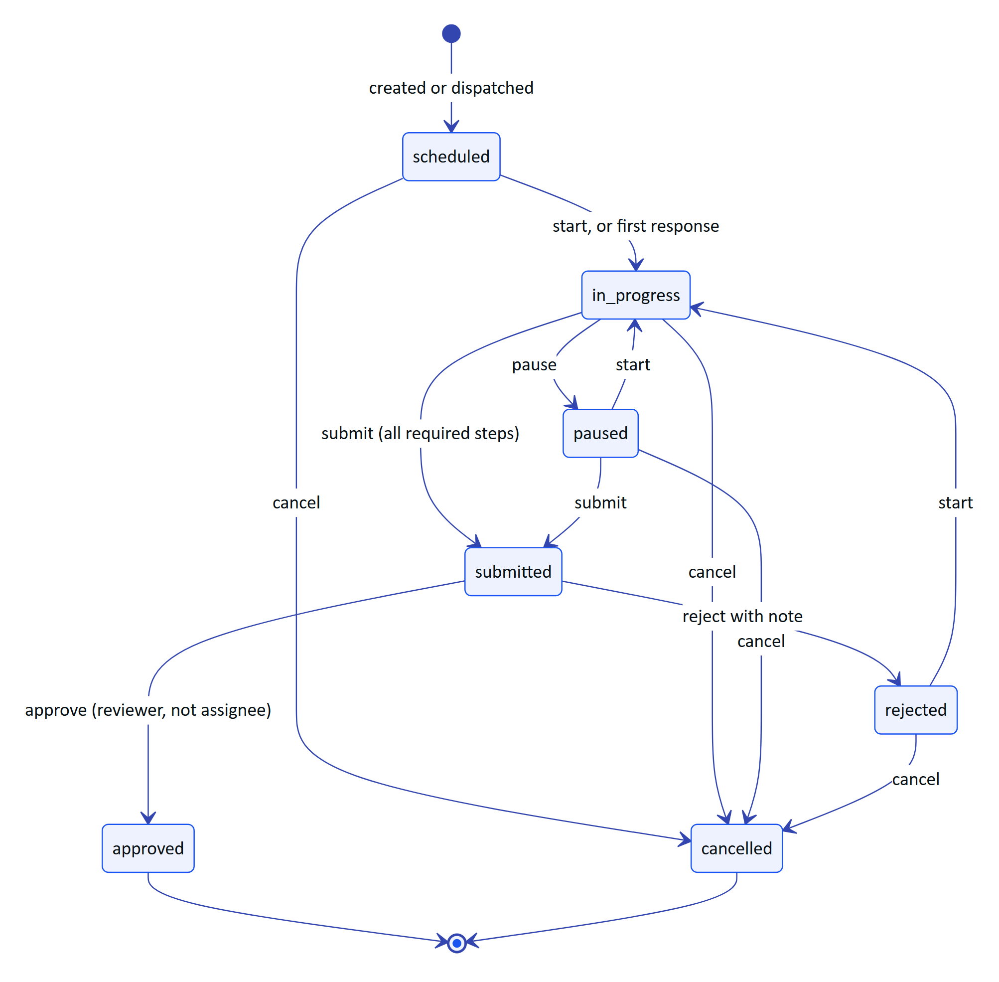
Figure 13. Inspection lifecycle (INSPECTION_TRANSITIONS in packages/domain/src/workflows.ts)
Submitting an inspection with abnormal findings automatically opens an inspection_followup maintenance task (priority high for more than one finding, otherwise medium) unless the client sends createFollowUp: false.
Table 18. Inspection endpoints
Method | Path | Auth | Permission | Purpose
GET | /api/inspection-templates | any | inspection.read | List templates
POST | /api/inspection-templates | user | inspection.manage | Create a template
PUT | /api/inspection-templates/:id | user | inspection.manage | Replace a template (versioned)
GET | /api/inspection-templates/:id | any | inspection.read | Template with usage counts
POST | /api/inspection-templates/:id/status | user | inspection.manage | Publish, unpublish, archive, restore
GET | /api/inspection-routes | any | inspection.read | List routes
POST | /api/inspection-routes | user | inspection.manage | Create a route
PUT | /api/inspection-routes/:id | user | inspection.manage | Replace a route
POST | /api/inspection-routes/:id/dispatch | user | inspection.manage | Create one inspection per stop
GET | /api/inspections | any | inspection.read | List inspections
POST | /api/inspections | user | inspection.manage | Create an inspection
GET | /api/inspections/:id | any | inspection.read | Inspection with responses and progress
PATCH | /api/inspections/:id | user | inspection.manage | Reassign, due date, priority
POST | /api/inspections/:id/responses | any | inspection.execute (assignee) | Sync step responses
POST | /api/inspections/:id/:action | any | per action | start, pause, submit, approve, reject, cancel

15.1 Templates

GET /api/inspection-templates
- Auth: any. Permission: inspection.read. Response: 200 { "templates": [...] } ordered by name.

POST /api/inspection-templates
- Auth: user. Permission: inspection.manage.
- Request:
{
"name": "Lift pump daily check",
"assetType": "pump",
"estimatedMinutes": 10,
"safetyNotices": ["Do not open the guard while the pump is running"],
"status": "draft",
"steps": [
{ "id": "noise", "kind": "check", "title": "No abnormal noise", "required": true },
{ "id": "vib", "kind": "reading", "title": "Vibration at drive end", "required": true, "measurand": "vibration", "unit": "mm/s", "expectedMin": 0, "expectedMax": 4.5 },
{ "id": "seal", "kind": "choice", "title": "Seal condition", "required": true, "options": ["Dry", "Weeping", "Leaking"], "abnormalOptions": ["Leaking"] },
{ "id": "photo", "kind": "photo", "title": "Photo of the gland", "required": false }
]
}
- Response: 201 { "template": { ... } } with version: 1.
- Errors: 400 validation_failed (1 to 60 steps, step ids unique and up to 40 characters, up to 10 safety notices).
- Side effects: audit inspection_template.created.

PUT /api/inspection-templates/:id
Replaces the template with the same body as create. The content version increments only when steps or safety notices change.
- Auth: user. Permission: inspection.manage. Response: 200 { "template": { ... } }.
- Errors: 404 not_found, 409 archived (archived templates must be restored first unless the body sets status to draft or published).
- Side effects: audit inspection_template.updated with field changes, stepsChanged and step counts.

GET /api/inspection-templates/:id
- Auth: any. Permission: inspection.read.
- Response: 200 { "template", "usage": { "total": 42, "open": 3 } }.

POST /api/inspection-templates/:id/status
- Auth: user. Permission: inspection.manage. Request: { "status": "draft" | "published" | "archived" }.
- Response: 200 { "template": { ... } }. Only published templates can be used for new inspections.
- Errors: 409 no_change, 404 not_found.
- Side effects: audit inspection_template.published, .archived, .restored or .unpublished.

15.2 Routes

GET /api/inspection-routes
- Auth: any. Permission: inspection.read. Query: siteId. Response: 200 { "routes": [...] }.

POST /api/inspection-routes
- Auth: user. Permission: inspection.manage and site scope.
- Request: { "siteId": "...", "name": "Morning round STP-1", "description": "...", "assetIds": ["...", "..."] } (1 to 100 stops, in walking order).
- Response: 201 { "route": { ... } }. Errors: 400 invalid_assets. Side effects: audit inspection_route.created.

PUT /api/inspection-routes/:id
- Auth: user. Permission: inspection.manage. Request: as create without siteId.
- Response: 200 { "route": { ... } }. Side effects: audit inspection_route.updated.

POST /api/inspection-routes/:id/dispatch
Creates one inspection per stop for one person. Each stop uses the published template whose assetType matches the asset's type, falling back to fallbackTemplateId.
- Auth: user. Permission: inspection.manage.
- Request: { "assignedTo": "<uuid>", "dueAt": "2026-10-22T11:00:00+05:30", "fallbackTemplateId": "<uuid>" }.
- Response: 201 { "created": 6, "inspectionIds": ["...", "..."] }.
- Side effects: per inspection: audit inspection.created, notification inspection_assigned, SSE inspection.updated.

15.3 Inspections

GET /api/inspections
- Auth: any. Permission: inspection.read. Glasses need the inspections screen.
- Query: status (a status, open for editable ones, or review for submitted), mine, siteId, assetId, overdue.
- Response: 200 { "inspections": [{ "id", "title", "status", "priority", "dueAt", "siteId", "assetId", "assignedTo", "startedAt", "submittedAt", "submittedVia", "routeId", "synthetic", "revision", "stepCount", "answered", "assetTag", "assetName", "assigneeName", "siteName" }] }, up to 300, work in progress first.
- Notes: callers without inspection.manage or inspection.review see only inspections assigned to them.

POST /api/inspections
- Auth: user. Permission: inspection.manage.
- Request: templateId, plus assetId or siteId, optional assignedTo, dueAt, priority (normal, high), title (defaults to template name and asset tag).
- Response: 201 { "inspection": { ... } } in scheduled.
- Errors: 400 invalid_template, 400 invalid_asset, 400 site_required, 400 invalid_assignee.
- Side effects: audit inspection.created, notification inspection_assigned, SSE inspection.updated.

GET /api/inspections/:id
- Auth: any. Permission: inspection.read. Glasses need the inspections screen.
- Response:
{
"inspection": {
"id": "91b2...", "title": "Lift pump daily check · P-101", "status": "in_progress", "revision": 4, "priority": "normal",
"steps": [{ "id": "noise", "kind": "check", "title": "No abnormal noise", "required": true }],
"safetyNotices": ["Do not open the guard while the pump is running"],
"asset": { "id": "a91f...", "tag": "P-101", "name": "Raw sewage lift pump 1", "type": "pump", "status": "operational", "positionX": 42, "positionY": 18 },
"assignee": { "id": "7c1e...", "name": "Karthik S" },
"progress": { "total": 4, "required": 3, "answered": 2, "requiredAnswered": 2, "abnormal": 0, "complete": false, "percent": 50 },
"responses": { "noise": { "value": { "kind": "check", "checked": true }, "outcome": "ok", "note": null, "recordedAt": "2026-10-22T08:02:11.000Z", "deviceId": "e0f1..." } },
"attachments": []
},
"followUps": [],
"permissions": { "execute": true, "manage": false, "review": false }
}
- Errors: 404 not_found (also when an executor asks for someone else's inspection).

PATCH /api/inspections/:id
- Auth: user. Permission: inspection.manage.
- Request: any of assignedTo (nullable), dueAt (nullable), priority.
- Response: 200 { "inspection": { ... } } with revision incremented.
- Errors: 409 not_editable (only scheduled, in progress, paused or returned inspections).
- Side effects: audit inspection.updated, notification to a new assignee, SSE inspection.updated.

POST /api/inspections/:id/responses
Batch sync of step responses, designed for glasses that work offline. Each operation carries a client-generated id and the time it was recorded on the device. The latest response per step (by recordedAt) wins.
- Auth: any. Permission: inspection.execute, and the caller must be the assignee. Glasses need the inspections screen and the record_inspection action.
- Request:
{
"ops": [
{ "opId": "op-1761120131-01", "stepId": "noise", "value": { "kind": "check", "checked": true }, "recordedAt": "2026-10-22T13:32:11+05:30" },
{ "opId": "op-1761120131-02", "stepId": "vib", "value": { "kind": "reading", "value": 5.2 }, "note": "Rising since last week", "recordedAt": "2026-10-22T13:33:40+05:30" }
]
}
- Response: 200 { "applied": 2, "duplicates": 0, "conflicts": [], "inspection": { ...view } }. Conflict reasons: unknown_step, kind_mismatch, timestamp_in_future, or inspection_<status> when the inspection is no longer editable (all ops are then returned as conflicts).
- Errors: 403 forbidden (not the assignee).
- Side effects: the first applied response moves a scheduled, paused or returned inspection to in_progress; SSE inspection.updated with progressChanged.

POST /api/inspections/:id/:action
action is start, pause, submit, approve, reject or cancel.
- Auth: any. Permission: start, pause and submit need inspection.execute and the assignee; approve and reject need inspection.review and someone other than the assignee; cancel needs inspection.manage. Glasses need the inspections screen and submit_inspection (for submit) or record_inspection (other actions).
- Request: { "note": "...", "expectedRevision": 4, "createFollowUp": true }, all optional. note is required for reject.
- Response: 200 { "inspection": { ...view }, "followUpId": "<uuid>" | null }.
- Errors: 403 forbidden, 409 revision_conflict, 409 invalid_transition, 400 note_required, 400 incomplete (with the progress object in details).
- Side effects: audit inspection.start, .pause, .submitted, .approved, .returned or .cancel; submit records submittedVia (glasses or console), may create the follow-up task (audit maintenance.created, SSE maintenance.updated) and notifies whoever assigned the work; approve and reject notify the assignee; SSE inspection.updated.

16 Maintenance module
File: apps/api/src/modules/maintenance.ts. Maintenance tasks are corrective, preventive, inspection follow-up or alarm follow-up work with an optional checklist. Anyone with maintenance.request can raise a task; planners (maintenance.manage) assign and edit; the assigned engineer (maintenance.execute) starts, holds and completes.
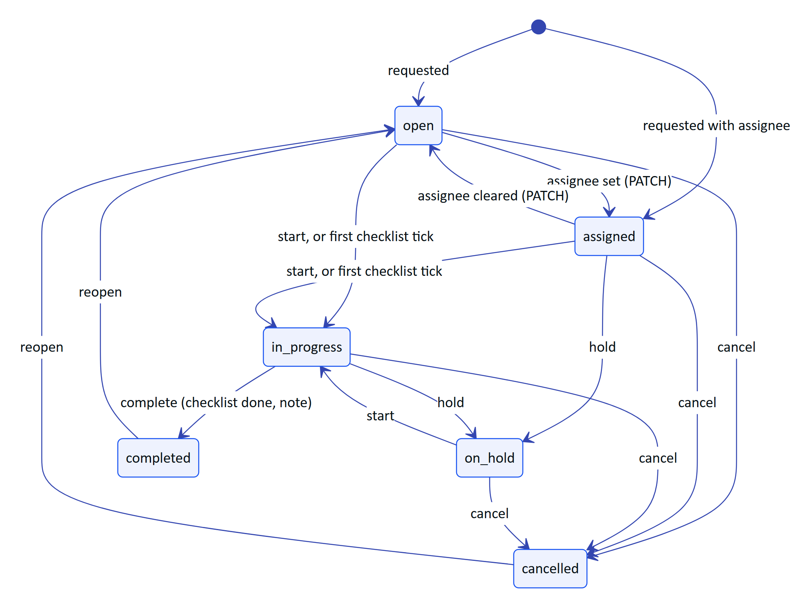
Figure 14. Maintenance task lifecycle (MAINTENANCE_TRANSITIONS in packages/domain/src/workflows.ts)
Reopening returns a task to assigned instead of open when it still has an assignee.
Table 19. Maintenance endpoints
Method | Path | Auth | Permission | Purpose
GET | /api/maintenance | any | maintenance.read | List tasks
POST | /api/maintenance | any | maintenance.request | Raise a task
GET | /api/maintenance/:id | any | maintenance.read | Task with activity log
PATCH | /api/maintenance/:id | user | maintenance.manage | Edit, assign, edit checklist
POST | /api/maintenance/:id/checklist/:itemId | any | manager, or assignee with execute rights | Tick or untick an item
POST | /api/maintenance/:id/notes | any | maintenance.read plus involvement | Add a note
POST | /api/maintenance/:id/:action | any | maintenance.manage, or assignee for start, hold, complete | Transition

GET /api/maintenance
- Auth: any. Permission: maintenance.read. Glasses need the tasks screen.
- Query: status (a status or open_all), priority (low, medium, high, urgent), siteId, assetId, mine.
- Response: 200 { "tasks": [{ ...task, "assetTag", "assetName", "assigneeName", "siteName" }] }, up to 300, in-progress and urgent first.

POST /api/maintenance
- Auth: any. Permission: maintenance.request; setting assignedTo needs maintenance.manage.
- Request:
{
"title": "Replace gland packing on P-101",
"description": "Seal leaking during morning round",
"assetId": "a91f...",
"kind": "corrective",
"priority": "high",
"assignedTo": "b2c3...",
"dueAt": "2026-10-23T12:00:00+05:30",
"sourceAlarmId": null,
"checklist": ["Isolate and lock out", "Replace packing", "Run and check for leaks"]
}
- Response: 201 { "task": { ... } }. Status is assigned with an assignee, otherwise open. A sourceAlarmId forces kind: "alarm_followup". Checklist items (up to 40) get 8-character ids.
- Errors: 400 site_required, 403 forbidden ("Only planners can assign maintenance"), 400 invalid_assignee, 400 invalid_alarm, 404 not_found.
- Side effects: activity created, audit maintenance.created, notification maintenance_assigned (severity critical for urgent), SSE maintenance.updated.

GET /api/maintenance/:id
- Auth: any. Permission: maintenance.read. Glasses need the tasks screen.
- Response: 200 { "task": { ..., "asset", "assignee", "attachments" }, "activity": [{ "action", "note", "actorName", "at" }], "permissions": { "manage", "execute" } }.

PATCH /api/maintenance/:id
- Auth: user. Permission: maintenance.manage.
- Request: any of title, description, priority, assignedTo, dueAt, kind, assetId, checklist. checklist is the full list: items with an existing id keep their completion state, items without an id are added, missing ids are removed.
- Response: 200 { "task": { ... } }.
- Errors: 409 not_editable (completed or cancelled), 400 validation_failed (inactive assignee, asset on another site, unknown checklist id).
- Side effects: activity assigned, updated and checklist_edited; audit maintenance.updated with changes; notification to a new assignee; SSE maintenance.updated.

POST /api/maintenance/:id/checklist/:itemId
- Auth: any. Permission: maintenance.manage, or the assignee holding maintenance.execute or inspection.execute. Glasses need the tasks screen and toggle_checklist action.
- Request: { "done": true }.
- Response: 200 { "task": { ... } }. The first tick moves an open or assigned task to in_progress.
- Errors: 403 forbidden, 409 not_editable, 404 not_found (item).
- Side effects: activity checklist_done or checklist_undone; SSE maintenance.updated.

POST /api/maintenance/:id/notes
- Auth: any. Permission: maintenance.read, and the caller must manage maintenance, be the assignee or be the requester. Request: { "note": "Waiting for packing from stores" }. Response: 200 { "ok": true }.

POST /api/maintenance/:id/:action
action is start, hold, complete, cancel or reopen.
- Auth: any. Permission: maintenance.manage for every action; the assignee with maintenance.execute may also start, hold and complete.
- Request: { "note": "..." }; required for complete.
- Response: 200 { "task": { ... } }.
- Errors: 403 forbidden, 409 invalid_transition, 400 checklist_incomplete, 400 note_required, 409 stale_state.
- Side effects: activity row, audit maintenance.<action>, notification maintenance_completed to the requester, SSE maintenance.updated.

17 Devices and pairing module
File: apps/api/src/modules/devices.ts. The pairing flow and device token rotation are described in the authentication chapter; this chapter lists the endpoints. Device records have three stored statuses (active, suspended, revoked); the console shows a derived state (paired, assigned, connected, disconnected, suspended, revoked) computed from status, assignment, lastSeenAt (90-second window) and open SSE streams.
Table 20. Device and pairing endpoints
Method | Path | Auth | Permission | Limit | Purpose
POST | /api/pairing/challenges | public | none | 10/min | Glasses request a pairing code
POST | /api/pairing/challenges/:id/poll | poll secret | none | 40/min | Glasses poll for approval and claim tokens
POST | /api/pairing/challenges/:id/cancel | poll secret | none | 20/min | Glasses cancel a challenge
GET | /api/pairing/lookup | user | device.pair | 10/min | Look up a code before approving
POST | /api/pairing/approve | user | device.pair (device.manage for others) | 10/min | Approve a code
POST | /api/pairing/deny | user | device.pair | 10/min | Deny a code
POST | /api/device/refresh | device refresh token | none | 30/min | Rotate device tokens
POST | /api/device/logout | device | none | global | Unpair from the glasses
GET | /api/device/context | device | none | global | Glasses home screen data
GET | /api/devices | user | device.read | global | Fleet list
GET | /api/devices/:id | user | device.read | global | Device detail and diagnostics
PATCH | /api/devices/:id | user | device.manage | global | Rename or move site
POST | /api/devices/:id/assign | user | device.manage | global | Reassign operator
POST | /api/devices/:id/suspend | user | device.manage | global | Suspend
POST | /api/devices/:id/reactivate | user | device.manage | global | Reactivate a suspended device
POST | /api/devices/:id/revoke | user | device.manage | global | Revoke permanently

POST /api/pairing/challenges
- Auth: public. Request: hardwareId (16 to 80 characters of [A-Za-z0-9_-], stable per install) and device with kind (hardware or simulator), optional model, name, appVersion, firmwareVersion, display (width, height).
- Response:
{
"challengeId": "3a9e...", "userCode": "K7RM-4QXT", "pollSecret": "q2Vt...", "expiresAt": "2026-10-22T08:19:03.000Z",
"pollIntervalS": 3, "verificationUri": "https://hydrisview.vercel.app/pair",
"verificationUriComplete": "https://hydrisview.vercel.app/pair?code=K7RM-4QXT"
}
- Errors: 503 pairing_unavailable. Notes: open challenges of the same hardwareId are cancelled.

POST /api/pairing/challenges/:id/poll
- Auth: { "pollSecret": "..." } in the body.
- Response: { "status": "pending", "expiresAt" }, { "status": "slow_down", "pollIntervalS": 3 }, { "status": "expired" | "denied" | "cancelled" }, or on approval { "status": "completed", "device": { "id", "name" }, "accessToken", "refreshToken" }. A second claim returns { "status": "completed", "error": "already_claimed" } without tokens.
- Errors: 404 not_found (unknown id or wrong secret).
- Side effects: creates or reuses the device, assigns the operator, audit device.paired, SSE device.paired and pairing.completed.

POST /api/pairing/challenges/:id/cancel
- Auth: poll secret. Response: 200 { "ok": true }. Errors: 404 not_found.

GET /api/pairing/lookup
- Auth: user. Permission: device.pair. Query: code (with or without the dash).
- Response: 200 { "challenge": { "code", "device", "requestedAt", "expiresAt" }, "organization", "sites", "assignees", "canAssignOthers", "existingDevice" }. Without device.manage, assignees contains only the caller.
- Errors: 400 invalid_code, 404 not_found (expired or used).

POST /api/pairing/approve
- Auth: user. Permission: device.pair; assigning someone else needs device.manage.
- Request: { "code": "K7RM-4QXT", "siteId": "<uuid>", "assigneeUserId": "<uuid>", "deviceName": "Karthik's glasses" }.
- Response: 200 { "ok": true, "challengeId": "..." }.
- Errors: 403 forbidden, 400 invalid_assignee, 400 assignee_no_site_access, 404 not_found, 409 device_owned_elsewhere, 409 already_used. Side effects: audit device.pairing_approved.

POST /api/pairing/deny
- Auth: user. Permission: device.pair. Request: { "code": "..." }. Response: 200 { "ok": true }.
- Side effects: audit device.pairing_denied; the glasses' next poll returns denied.

POST /api/device/refresh
- Auth: { "refreshToken": "hgd_..." } (up to 120 characters).
- Response: 200 { "accessToken", "refreshToken" }.
- Errors: 401 device_revoked, 401 device_session_invalid, 401 device_session_expired, 403 device_suspended, 403 device_unassigned.

POST /api/device/logout
- Auth: device (a user token returns 403 forbidden). Response: 204.
- Side effects: device sessions revoked and session version bumped.

GET /api/device/context
Everything the glasses need for the home screen in one call, filtered by the device's effective UI profile: sections for disabled screens are omitted on the server, not just hidden.
- Auth: device.
- Response: 200 { "device", "operator", "organization", "site", "role", "profile", "inspections", "alarms", "tasks", "map", "assets", "measurements", "serverTime" }. inspections, alarms and tasks hold up to 20 open items of the operator and site; map gives the site layout in metres, process area polygons and asset pins; each measurement carries freshness and threshold (alarm, out_of_range, normal).

GET /api/devices
- Auth: user. Permission: device.read.
- Response: 200 { "devices": [{ ...device, "siteName", "assignee": { "id", "name", "since" }, "streamOpen", "state" }] }. hardwareId is never returned.

GET /api/devices/:id
- Auth: user. Permission: device.read.
- Response: 200 { "device", "assignments", "activeSessions", "events", "diagnostics", "canManage", "effectiveProfile" }. diagnostics.battery is null: the current integration does not expose hardware sensors.

PATCH /api/devices/:id
- Auth: user. Permission: device.manage. Request: name (2 to 60), siteId.
- Response: 200 { "device" }. Side effects: audit device.updated; a site change sends device.context_changed (site_changed).

POST /api/devices/:id/assign
- Auth: user. Permission: device.manage. Request: { "userId": "<uuid>", "reason": "Shift handover" }.
- Response: 200 { "ok": true } or { "ok": true, "unchanged": true }.
- Errors: 409 device_not_active, 400 invalid_assignee, 404 not_found.
- Side effects: session version bumped (the glasses refresh into the new operator), audit device.reassigned, SSE device.context_changed and device.updated.

POST /api/devices/:id/suspend, /reactivate, /revoke
- Auth: user. Permission: device.manage. Request: { "reason": "Lost on site" }; required for revoke.
- Response: 200 { "ok": true, "status": "suspended" | "active" | "revoked" }.
- Errors: 409 device_revoked, 409 invalid_transition (reactivate only from suspended), 400 reason_required.
- Side effects: session version bumped; revoke also ends device sessions and the assignment; audit device.suspended, device.reactivated or device.revoked; SSE device.revoked or device.context_changed, and device.updated.

18 Realtime module
File: apps/api/src/modules/realtime.ts, with the serverless variant in apps/web/src/app/api/events/stream/route.ts.

GET /api/events/stream
- Auth: any, as Authorization: Bearer. Request: optional Last-Event-ID header or lastEventId query.
- Response: 200 text/event-stream, described in the realtime chapter.
- Errors: 401 unauthorized, 503 realtime_misconfigured (serverless route without REALTIME_MODE=db).

19 Insights module
File: apps/api/src/modules/insights.ts. Dashboards, reports, grounded procedure retrieval and search.
Table 21. Insights endpoints
Method | Path | Auth | Permission | Purpose
GET | /api/overview | any | scope only | Overview dashboard
GET | /api/reports/:kind | any | report.read, report.export for CSV | Reports
GET | /api/assist | any | document.read | Approved procedure passages and live asset data
GET | /api/search | any | scope only | Command palette search

GET /api/overview
- Query: siteId (optional).
- Response: 200 { "generatedAt", "alarms": { "active", "critical", "open", "last24h" }, "inspections": { "due", "overdue", "review", "done7d" }, "maintenance": { "open", "urgent" }, "devices": { "registered", "connected" }, "activeOperators", "sites", "assetHealth", "metrics", "recentAlarms", "activity", "alarmTrend" }. alarmTrend covers 14 days; metrics are up to 12 continuous pH, DO, turbidity, flow, level and vibration sensors.

GET /api/reports/:kind
- Path: kind is inspections, alarms, maintenance, devices or operators.
- Query: from, to (default last 30 days), siteId, assetId, userId, severity, format (json or csv).
- Response: JSON { "kind", "from", "to", "rows", "summary" } (up to 5000 rows) or a CSV attachment. Summaries include median minutes to acknowledge (alarms), completion and on-time rates (inspections) and median hours to complete (maintenance).
- Errors: 400 invalid_range. Side effects: CSV writes audit report.exported.

GET /api/assist
Grounded retrieval only: it never generates procedures or issues commands. Glasses need ask_ai or view_sops.
- Query: q (2 to 200), assetId (optional).
- Response: 200 { "query", "sources": [{ "id", "title", "kind", "version", "rank", "passage" }], "asset", "telemetry", "glossary", "notice" }, up to five approved documents ranked by Postgres full-text search, with a safety notice.

GET /api/search
- Query: q (1 to 80). Response: 200 { "assets", "sensors", "documents", "people" }, each with id, label, sub.

20 Voice assistant module
File: apps/api/src/modules/voice-assistant.ts. "Hey Hydris" answers spoken questions from the caller's own data. With an Anthropic credential configured it uses Claude (claude-opus-5-5) with five read-only tools (readings, open alarms, my work, asset status, procedure search), all scoped by RLS and site scope. Otherwise, or if the model call fails, a deterministic intent engine answers. Neither engine can change data.

POST /api/assistant/ask
- Auth: any. Limit: 60 per minute.
- Request: { "text": "what is the current pH", "history": [{ "role": "user", "text": "..." }] } (text 1 to 500, up to 8 history turns).
- Response:
{
"answer": "Current pH at Aeration tank 1 is 7.12, measured 40 seconds ago, within the typical range.",
"facts": [{ "label": "pH · Aeration tank 1", "value": "7.12", "unit": "pH", "at": "2026-10-22T08:13:20.000Z", "source": "sensor", "ref": "AT-101-PH" }],
"intent": "reading",
"engine": "hydris-rules"
}
- Notes: engine is claude-opus-5-5 or hydris-rules; intent is llm for model answers, otherwise alarms, my_work, reading, asset, procedure, help or unknown.
curl -s -X POST https://hydrisview.vercel.app/api/assistant/ask \
-H "authorization: Bearer $TOKEN" -H "content-type: application/json" \
-d '{"text":"Do I have any critical alarms?"}'

21 Audit documents module
File: apps/api/src/modules/audit-docs.ts. Paper records (lab sheets, logs, permits) are captured as page images with on-device OCR, optionally refined by a vision model, cross-checked value by value, reviewed by a person, verified and then approved by a different person, and exported as a searchable PDF.
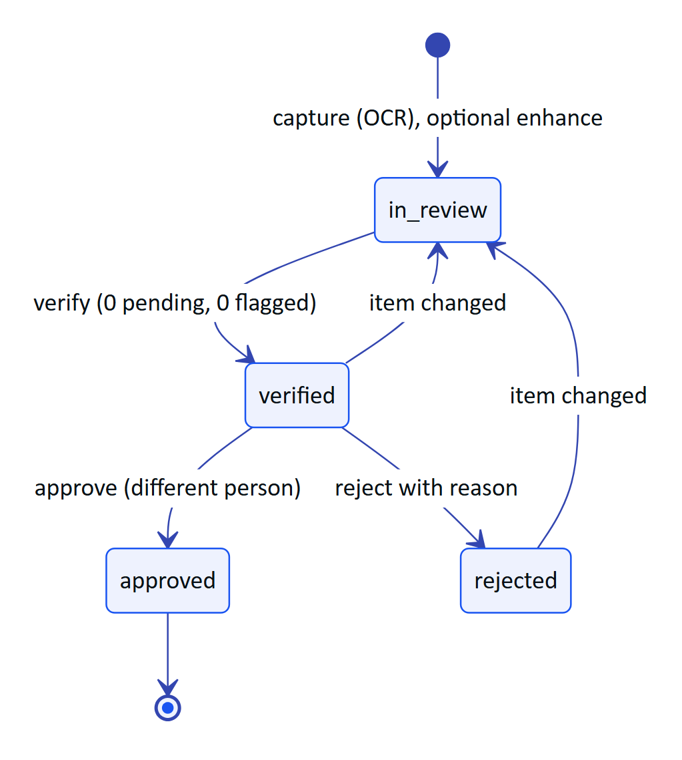
Figure 15. Audit document lifecycle: capture, review, verification and independent approval
Table 22. Audit document endpoints
Method | Path | Auth | Permission | Purpose
GET | /api/audit-docs/capabilities | any | none | Engine availability and limits
GET | /api/audit-docs | any | auditdoc.read | List (bare array)
GET | /api/audit-docs/:id | any | auditdoc.read | Detail with extraction and events
GET | /api/audit-docs/:id/pages/:pageNo | any | auditdoc.read | Page image
GET | /api/audit-docs/:id/pdf | any | auditdoc.read | Searchable PDF
POST | /api/audit-docs | any | auditdoc.capture | Capture
POST | /api/audit-docs/:id/enhance | any | auditdoc.capture | Run the vision engine
PATCH | /api/audit-docs/:id/items/:itemId | any | auditdoc.verify or auditdoc.capture | Review one field or table
POST | /api/audit-docs/:id/confirm-agreed | any | auditdoc.verify or auditdoc.capture | Bulk-confirm agreed values
POST | /api/audit-docs/:id/verify | user | auditdoc.verify | Sign off the review
POST | /api/audit-docs/:id/approve | user | auditdoc.approve | Approve or reject
PATCH | /api/audit-docs/:id | any | auditdoc.verify or auditdoc.capture | Rename

GET /api/audit-docs/capabilities
- Response: 200 { "vision": true, "visionEngine": "vision:claude-opus-5-5", "maxPages": 6, "maxPageBytes": 921600 }.

GET /api/audit-docs
- Query: status (processing, in_review, verified, approved, rejected), mine.
- Response: 200 [{ "id", "title", "docType", "status", "siteName", "pageCount", "capturedVia", "capturedBy", "engines", "aiStatus", "agreement", "fields", "tables", "figures", "review", "attention", ... }], up to 200.

GET /api/audit-docs/:id
- Response: the summary plus extraction, revision, aiError, verifiedBy, approvedBy, rejectedReason, pages, events (with viaGlasses) and permissions (review, verify, approve).

GET /api/audit-docs/:id/pages/:pageNo and GET /api/audit-docs/:id/pdf
- Response: the page image (private, max-age=3600) or application/pdf attachment with OCR text, extracted values and sign-off record.

POST /api/audit-docs
- Body limit: 8 MB. Request: title, siteId, assetId (optional), source (mobile, optional) and pages (1 to 6): each with mime (image/jpeg or image/png), base64 data (at most 900 KB decoded), width, height, readings (1 to 3 OCR passes with engine, text, confidence and word boxes) and optional figures.
curl -s -X POST https://hydrisview.vercel.app/api/audit-docs \
-H "authorization: Bearer $TOKEN" -H "content-type: application/json" \
--data-binary @scan.json
- Response: 201 summary with status: "in_review" and aiStatus pending or unavailable.
- Errors: 400 page_too_large, 400 invalid_image, 404 not_found (site).
- Side effects: capturedVia is glasses, mobile or console; audit auditdoc.captured; SSE auditdoc.updated.

POST /api/audit-docs/:id/enhance
- Response: 200 summary, or { "aiStatus": "unavailable" | "failed", "message" }.
- Errors: 409 review_started, 409 stale.

PATCH /api/audit-docs/:id/items/:itemId
- Request: action (confirm, correct, flag, reset), value and unit (fields), header and rows (tables), note, expectedRevision.
- Response: 200 { "revision", "status", "review", "item" }. The first extracted value is kept in extracted.
- Errors: 409 locked, 409 stale, 400 value_required, 400 rows_required, 404 not_found.
- Notes: editing a verified or rejected document reopens the review.

POST /api/audit-docs/:id/confirm-agreed
Confirms pending fields read by more than one engine that agree with confidence of at least 0.8.
- Response: 200 { "revision", "review" }. Errors: 409 not_in_review, 409 stale.

POST /api/audit-docs/:id/verify
- Auth: user only. Request: { "note": "..." } optional. Response: 200 { "status": "verified", "revision" }.
- Errors: 409 not_in_review, 400 flagged_items, 400 review_incomplete. Side effects: audit auditdoc.verified.

POST /api/audit-docs/:id/approve
- Auth: user only. Request: { "decision": "approve" | "reject", "note": "..." } (note required to reject).
- Response: 200 { "status", "revision" }.
- Errors: 409 not_verified, 403 forbidden (same person as verifier, outside demo tenants), 400 reason_required. Side effects: audit auditdoc.approved or auditdoc.rejected.

PATCH /api/audit-docs/:id
- Request: { "title": "..." } (2 to 160). Response: 200 { "title", "revision" }. Errors: 409 locked.

22 Glasses UI profiles module
File: apps/api/src/modules/ui-profiles.ts. UI profiles control which screens, widgets, measurements and actions the glasses show. Profiles are versioned (one draft, one published, superseded history) and assigned by organization, role, user or device; the most specific assignment wins (device, user, role, organization, built-in default). Reading requires an organization administrator or factory manager; editing requires an organization administrator.
Table 23. UI profile endpoints
Method | Path | Access | Purpose
GET | /api/ui-profiles | read | Profiles with published version and draft flag
POST | /api/ui-profiles | edit | Create (optionally copy another)
GET | /api/ui-profiles/:id | read | Versions with change lists, assignments
PATCH | /api/ui-profiles/:id | edit | Rename, describe
POST | /api/ui-profiles/:id/archive | edit | Archive an unassigned profile
PUT | /api/ui-profiles/:id/draft | edit | Save the draft config
DELETE | /api/ui-profiles/:id/draft | edit | Discard the draft
POST | /api/ui-profiles/:id/publish | edit | Publish the draft
POST | /api/ui-profiles/:id/rollback | edit | Republish an earlier version as a new version
GET | /api/ui-profile-assignments | read | List assignments
POST | /api/ui-profile-assignments | edit | Create or replace an assignment
DELETE | /api/ui-profile-assignments/:id | edit | Remove an assignment
GET | /api/ui-profiles-effective | read | Resolve the profile for a device or user

PUT /api/ui-profiles/:id/draft
- Request:
{
"config": {
"schemaVersion": 1,
"screens": [{ "id": "map", "enabled": false }],
"widgets": [{ "id": "alarm_summary", "visible": true }],
"measurements": { "allow": ["ph", "dissolved_oxygen", "vibration"], "orderByAssetType": { "pump": ["vibration", "motor_current"] } },
"actions": { "acknowledge_alarm": true, "record_inspection": true, "submit_inspection": true, "toggle_checklist": true, "ask_ai": true, "view_sops": true, "view_map": false, "mark_notifications_read": true },
"layout": { "density": "compact", "textScale": 1.1, "handedness": "right" }
},
"notes": "Hide the map for STP-1 operators"
}
- Response: 200 { "draft": { ... } }. Errors: 409 profile_archived.
- Notes: screens are home, alerts, inspections, tasks, map, measurements, assets, sops, ai, scan, notifications, status.

POST /api/ui-profiles/:id/publish and /rollback
- Request: publish { "notes": "..." }; rollback { "versionId": "<uuid>", "notes": "..." }.
- Response: 200 { "version", "affectedDevices": 4 }.
- Errors: 400 no_draft, 409 profile_archived, 400 cannot_rollback_to_draft, 409 already_published.
- Side effects: audit ui_profile.published or ui_profile.rolled_back; SSE device.profile_changed to affected glasses and ui_profile.updated.

POST /api/ui-profile-assignments
- Request: { "scope": "org" | "role" | "user" | "device", "profileId", "role" | "userId" | "deviceId" }.
- Response: 201 (new) or 200 (replaced) { "assignment", "replaced", "affectedDevices" }.
- Errors: 400 invalid_profile, 400 invalid_user, 400 invalid_device.

Other UI profile routes
POST /api/ui-profiles takes { name, description?, copyFromProfileId? } and returns 201 { profile } with a v1 draft. PATCH takes { name?, description? }. Archive returns 409 profile_assigned while assignments exist. DELETE .../draft returns 404 not_found without a draft. GET /api/ui-profiles-effective?deviceId=&userId= returns { subject, effective: { profileId, name, version, source, config } } or 400 subject_required. Every write is audited under ui_profile.*.

23 Simulation module
File: apps/api/src/modules/simulation.ts. Demo tenants only: deterministic scenarios feed synthetic readings through the normal ingestion pipeline, which refuses simulator data for customer tenants.

GET /api/simulation
- Auth: any. Response: 200 { "available", "canControl", "scenarios", "stepSeconds": 5, "running" }. Scenarios: normal_operations, pump_vibration, tank_high_level, abnormal_ph, scheduled_inspection, equipment_offline, glasses_network_loss, high_priority_alert, maintenance_checklist, device_reassignment.

POST /api/simulation/start
- Permission: simulation.control. Request: { "scenario": "pump_vibration", "siteId": "<uuid>" }.
- Response: 201 { "run" }. Runs on the same site are stopped first.
- Errors: 403 forbidden (not a demo organization, simulator disabled), 404 not_found.

POST /api/simulation/stop
- Permission: simulation.control. Response: 200 { "ok": true }. Errors: 409 not_running.

24 Public website module
File: apps/api/src/modules/public.ts.

POST /api/public/inquiries
- Auth: public. Limit: 5 per 10 minutes.
- Request: kind (contact or demo), name, email, optional company, jobTitle, phone, siteCount (1, 2-5, 6-20, 20+), message, consent: true (required), website (honeypot, must be empty), startedAt (epoch milliseconds when the form opened).
- Response: 201 { "ok": true }. Errors: 400 too_fast, 400 validation_failed.
- Notes: the IP is stored only as a salted hash; consent version 2026-10 is recorded.

25 Background jobs and cron
File: apps/api/src/jobs.ts. Hydris has no outbound webhooks today (see the planned API chapter). Background work runs inside the API.
Table 24. Background jobs
Job | Long-running server | Serverless (Vercel)
Stale-data alarm rules | Every 30 s | Each cron call
Expire pairing challenges | Every 60 s | Each cron call
Prune realtime_events older than 24 h | Hourly (db mode) | Each cron call
Advance running simulations | Timers every 5 s | Each cron call, plus lazily on API activity in demo mode

GET /api/cron
- Auth: Authorization: Bearer <CRON_SECRET>, compared in constant time. The root vercel.json schedules it daily at 03:00 UTC (0 3 * * *, a Hobby plan constraint; Pro deployments can run it every minute).
- Response: 200 { "ok": true, "ms": 412, "report": { "staleRules": "ok", "pairingExpiry": "ok", "realtimePruned": 120, "simulationSteps": 1 } }.
- Errors: 401 unauthorized.

26 Client libraries

26.1 Web console fetch wrapper
apps/web/src/lib/api.ts. The access token lives only in memory; the refresh token is the httpOnly cookie, which page scripts cannot read. api() adds the bearer header, and on a 401 performs one single-flight POST /auth/refresh and retries once; if refresh fails it calls the session-lost handler. Errors become ApiError(status, code, message, details) from the envelope. apiBlob() and download() fetch images, PDFs and CSVs with the header so tokens never appear in URLs. apps/web/src/lib/realtime.ts reads the SSE stream through fetch, tracks Last-Event-ID, refreshes on 401 or session.ended, and reconnects with backoff capped at 15 seconds.

26.2 Glasses device link
apps/web/src/glasses/link.ts and data.ts. DeviceLink owns the install hardwareId, the pairing flow, the device refresh token (in localStorage in the browser runtime; a native runtime should supply a hardware-backed SecureStore), single-flight refresh, one retry on 401, and the offline queue of inspection operations. Responses for read screens are cached so the glasses keep showing the last known data offline.

26.3 Android OkHttp client
apps/android/app/src/main/java/ai/hydris/field/data/HydrisApi.kt and Repository.kt. One OkHttpClient with a persistent, encrypted cookie jar for hg_refresh and hg_demo (15 s connect, 90 s read timeouts for uploads). A mutex-serialized refresh() handles 401s, except on login and demo calls. A second credential channel, deviceCall(), uses stored device tokens and /device/refresh, so scans taken with paired Ray-Ban Meta glasses are attributed to the device. events() reads SSE on a separate client without read timeout and resumes with Last-Event-ID.

27 Change history and deprecation policy
Table 25. API change history (from the git log)
Date | Change
2026-10-15 | Whole stack on Vercel: in-process API route, DB-backed realtime, cron, Blob storage. Demo mode with POST /api/auth/demo
2026-10-21 | Named demo guests; pairing shared across instances; POST /api/device/logout
2026-10-21 | Audit documents module (12 routes); voice assistant POST /api/assistant/ask
2026-10-22 | Android client; audit capture accepts source: "mobile"

Deprecation policy for this API:
- Additive changes (new routes, optional fields, new event types, new error codes) ship without notice. Clients must ignore unknown fields and events.
- Removing or renaming a route, field or error code used by a shipped client needs a release in which old and new coexist, and a changelog entry here.
- Versioned paths (/api/ingest/v1) are kept for at least 12 months after a successor is published, because gateway firmware updates slowly.
- The future public integration API will carry a version segment and a published sunset header policy.

28 Planned API
NOTE
Everything in this chapter is Planned. None of it exists in the code today.

- Public REST API for integrations. A versioned /api/v1 surface for CMMS, ERP and historian integrations with organization-scoped API clients (client credentials), read access to sites, assets, readings, alarms and work, and scoped writes for work orders.
- OpenAPI generation. Generate an OpenAPI 3.1 document from the existing zod schemas and publish it with the public API, so integrators get typed clients and this reference can be checked against it automatically.
- MQTT and OPC UA ingestion. Gateways already record protocol (https, mqtt, opcua), but only HTTPS ingestion exists. Planned: an MQTT bridge and an OPC UA client that feed the same ingest() pipeline.
- Outbound webhooks. Signed callbacks for alarm and work events, with retries and a delivery log.
- Shared rate-limit store. Redis or Postgres-backed limits so serverless instances enforce one shared budget.

